

T-Corker Operations Manual

V1.0

TABLE OF CONTENTS

1.1 | SAFETY |  | Page
 | 1.2 | GENERAL SAFETY | 3
 | 1.3 | ELECTRICAL SHOCK | 3
 | 1.4 | CONTACT MATERIALS COMPATIBILITY | 3
 | 1.5 | SAFETY COMPLIANCE LIABILITY | 4
 | 1.6 | CONVENTIONS | 4
2.1 | MACHINE FEATURES & SPECIFICATIONS
 | 2.2 | INTRODUCTION | 5
 | 2.3 | FEATURES & BENEFITS | 5
 | 2.4 | PERFORMANCE SPECIFICATIONS | 5
3.1 | INSTALLATION & START-UP
 | 3.2 | INSTALLATION PROCEDURES | 6
 | 3.3 | START-UP & COMMISSIONING | 6
4.1 | MECHANICAL ADJUSTMENTS
 | 4.2 | THEORY OF OPERATION | 8
 | 4.3 | CORK DELIVERY AND POSITIONING | 8
 | 4.4 | CONTAINER GUIDE RAIL AND INDEXING GATE ADJUSTMENTS | 10
 | 4.5 | CONTAINER SENSOR ADJUSTMENTS AND LOCATIONS | 11
5.1 | CONTROL PANEL
 | 5.2 | MAIN CONTROL SCREEN | 12
 | 5.3 | SETUP PAGE | 13
 | 5.4 | INPUT / OUTPUT PAGE | 13
 | 5.5 | TIMERS PAGE | 14
 | 5.6 | Manual Page 16
 | 5.7 | ASU 16
6.1 | ELECTRICAL
 | 6.2 | MAIN CONTROL BOX | 16
 | 6.3 | FRONT PANEL CONTROLS | 16
 | 6.4 | AIR SOLENOIDS | 17
7.1 | TROUBLESHOOTING
 | 7.2 | GENERAL TROUBLESHOOTING | 17
8.1 | SERVICING
 | 8.2 | CLEANING PROCEDURE | 18
9.1 | FACTORY CONTACT INFORMATION
 | 9.2 | CONTACT APEX DIRECTLY | 18

1.1 SAFETY

1.2 GENERAL SAFETY

Apex Filling Systems, LLC (APEX) manufactures and designs all of its products so they can be operated safely. However, the primary responsibility for safety rests with those who use and maintain these products. The following safety precautions are offered as a guide that if conscientiously followed, will minimize the possibility of accidents throughout the useful life of this equipment. The safety of personnel, equipment and plant facilities should be considered during equipment operation and with each changeover of product, or any machine modifications.

Only those who have been trained and delegated to do so and have read and understood this operator's manual should operate the equipment. Failure to follow the instructions, procedures and safety precautions in this manual can result in accidents and injuries.

DO NOT modify the equipment except with written factory approval. Unauthorized equipment modifications will void the warranty.

Each day walk around the equipment and inspect for leaks, loose parts, missing or damaged components, and parts out of adjustment. Perform all recommended maintenance noted in this manual.

EQUIPMENT SHOULD ALWAYS BE DE-ENERGIZED (POWER AND AIR) BEFORE MAKING MECHANICAL ADJUSTMENTS.

1.3 ELECTRICAL SHOCK

To avoid electrical shock hazard, make sure this equipment is properly grounded.

Dangerous voltages are present within the electrical enclosures. DO NOT operate this equipment with electrical covers open or removed.

Keep all parts of the body, hand held tools, or other conductive objects away from exposed live-parts of the electrical system. Maintain dry footing and stand on insulating surfaces. DO NOT contact any portion of the equipment when adjusting or making repair to exposed live parts of electrical system.

Attempt repairs only in a clean, dry, well-lighted, and ventilated area.

1.4 CONTACT MATERIALS COMPATIBILITY

APEX endeavors to make all contact parts compatible with buyer's products, if known. Because of the wide variety of possible products, Apex Filling Systems, LLC cannot be responsible or liable for ensuring compatibility of contact material with the products.

Evaluate material compatibility prior to machine use. Failure to follow this procedure can result in machine damage, fire, operator injury or death

1.5 SAFETY COMPLIANCE LIABILITY

APEX endeavors to make machinery as safe to operate as possible. National, state and local laws related to safety in the workplace apply primarily to the responsibilities of the employer, and not the equipment manufacturer. The seller agrees to cooperate with the buyer in finding feasible answers to compliance problems. However, because APEX has little control of the many factors which may significantly affect the environment in which this equipment is installed, the seller does not warrant this equipment to be in compliance with OSHA or any like state or local laws or regulations. It is the buyer's responsibility to provide the modifications necessary to assure compliance with the laws and regulations at the point of installation.

A complete inspection of product is necessary until the machinery is proven to produce acceptable results. This should also be performed after every changeover.

1.6 CONVENTIONS

To ensure the safety of personnel which will install, adjust, maintain and operate this equipment, it is imperative that they understand the dangers, warnings and caution notices. It is important to understand the signal words that may be used throughout this manual.

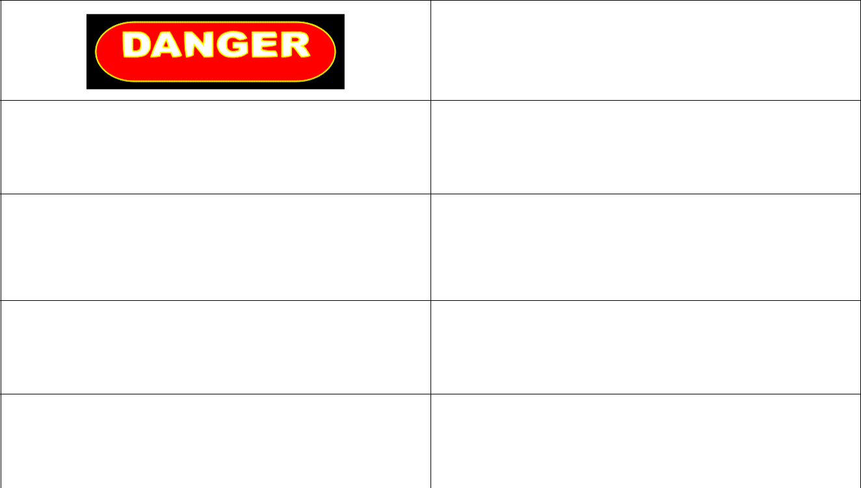
Alerts to immediate hazard, which will result in
death or severe personal injury, if not avoided



Alerts to a hazard which will result in serious injury, or death in some cases, if not avoided.


Alerts to a potential hazard that may result in a serious personal injury, if not avoided. It also alerts against an unsafe practice that will permanently damage equipment or property.


Indicates a suggestion as to how to use or adjust



the equipment for best product results.




Points out a proper use that will avoid damage to the equipment, or will extend the life of the parts.



2.1 MACHINE FEATURES & SPECIFICATIONS

2.2 INTRODUCTION

APEX machines are designed to be easy to setup and maintain, capable of providing years of reliable service. Versatile by design, APEX machines can accommodate a wide variety of product and container configurations, often without the need for change parts. Modular design allows for fully automatic or semi-automatic systems. Tool-less adjustments are available, and allow for easy and quick changeover for various product and container combinations. Operator controls are easily accessed via the front panel of the unit.

2.3 FEATURES & BENEFITS

Easy Changeover

Simple mechanical adjustment for different bottle sizes. Quick to changeover, simple to use and easy to clean

Robust

Anodized aluminum and stainless steel shells, frames, legs and housings maximize the working life of your machine, and minimize maintenance costs and downtime

Customizable

Whatever the production need, APEX has a design to meet

Flexible

Versatility and Simplicity are intrinsic to the design. Many container sizes and shapes, and many products can be run on one machine

2.4 AIR SPECIFICATIONS & REQUIREMENTS

Compressed Air Consumption: Clean, dry (non-oiled) compressed air 90-100psi / up to 20cfm depending on options

Refer to machine specific documentation if applicable.

.

3.1 INSTALLATION & START-UP

3.2 INSTALLATION PROCEDURES

The T-Corker assembly should be placed on a solid, level foundation, with the plunger head centered over the container conveyor. The T-Corker frame should be leveled using threaded leveling pads or other suitable means to secure the equipment in place. Electrical connections should be properly terminated into the main electrical enclosure by properly trained technicians, and appropriate supply voltage, proper phase and adequate supply amperage should be verified prior to powering up the equipment.

3.3 START-UP & COMMISSIONING

This manual should be read completely before powering-up the machine. Commissioning of the machine should be performed by a trained technician only after complete understanding of the machine, and with products that match samples indicated to APEX Consultants, LLC if supplied. After the machine is adjusted for the bottle and product combination, the machine can be put into operation with the following steps.


Check the machine to see that guards are in place

Check the mechanical system for loose or missing parts

- Ensure the E-STOP button is depressed, and the unit is clear of personnel.
Figure 3-1
Emergency Stop


- Ensure the filter regulator has a compressed air supply at the appropriate air pressure and rotate the main power disconnect clockwise to ON

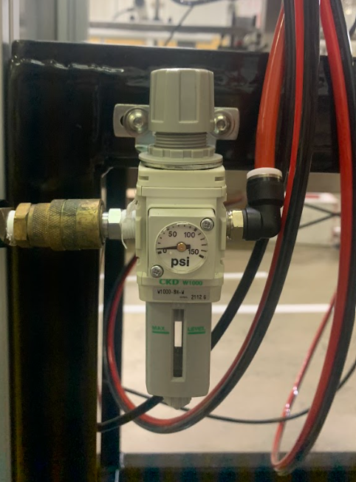

Figure 3-2
Main Disconnect

Figure 3-3
Main Air Disconnect and Filter Regulator

- Verify that sufficient containers and corks are available to be supplied to the T-Corker machine

- On the operator interface, press Cycle to begin the container indexing and cycle.

- If machine indexing does not perform properly, refer to the appropriate mechanical adjustments (Sec 4.1) to rectify, or adjust the appropriate indexing program timers (see controller manual for detailed adjustments)

4.1 MECHANICAL ADJUSTMENTS

4.2 THEORY OF OPERATION

APEX T-Corkers utilize a container conveying system, typically a flat tabletop chained conveyor, to move containers into and out of the corking area. Container location is typically controlled with the use of guide rails, and indexed using air cylinders (commonly referred as “gates” or “pins”) to stop and release containers.

Corks are typically sorted with a Pocket sorter sending corks down a chute to feed corker.

The corking cycle starts once the containers have been sensed via an electrical sensor. When the bottles trigger the infeed sensor, the bottle is indexed, and the plunger cylinder lowers the plunger head to push a cork into the container, sealing the neck airtight.

Once the containers are corked, the containers are indexed out of the corking area to down-line operations (neck banding, labeling, etc), and empty containers are indexed in to the corking area, ready for the next corking cycle.

In some inline setups there will be no indexing gates and ax containers come past the bottle sensor a delay timer expires and a cork is applied.

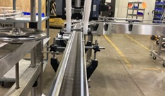
4.3 CORK DELIVERY AND POSITIONING

Before completing any fine adjustments, the T-Corker’s plunger must be centered with the conveyor, and the T-Corker machine must be leveled. This will help the cork sorting and the machine’s ease of pressing the cork into the container. See Figure 4-1 to see the T-Corker machine properly placed over the conveyor.
Figure 4-1
The T-Corker’s plunger is centered above the conveyor and mounted.

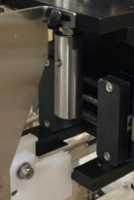

The plunger height relative to the cork should be set to roughly 1/8” above the top of the cork as shown in Figure 4-5. If needed, the plunger height can be set by loosening the set screw on the plunger, and re-tightening the set screw once proper adjustments have been made.

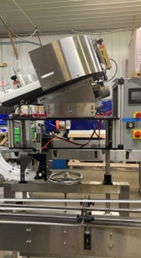

Figure 4-5
The T-Corker Plunger

The overall height can be adjusted with the large handle as shown in Figure 4-6. The corker’s height can be easily adjusted as needed with corresponding container heights.

Figure 4-6
T-Corker with Height Adjustment Handle

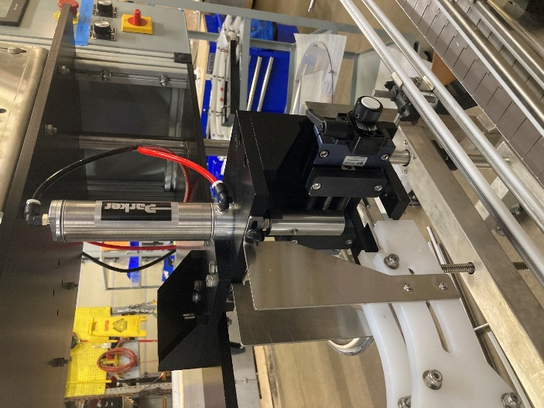
Cork Stop Rod
Bombay Doors
The Chute should be centered with hardware here
The Bombay doors can be adjusted in width by turning the knob here.

4.4 CONTAINER GUIDE RAIL AND INDEXING GATE ADJUSTMENTS

For containers to move properly down the conveyor, guide rails must be adjusted so that containers move smoothly, without binding, in a uniform manner. Guide rails will typically be set toward the base of the container for best results.

Difficult-to-control containers may require an alternate setup (multiple rails, special containment, etc) to effectively control the location of the containers. Guide rails are typically adjusted in/out and up/down with turnbuckles which hold the guide rail rods in place, as shown in Figure 4-7.

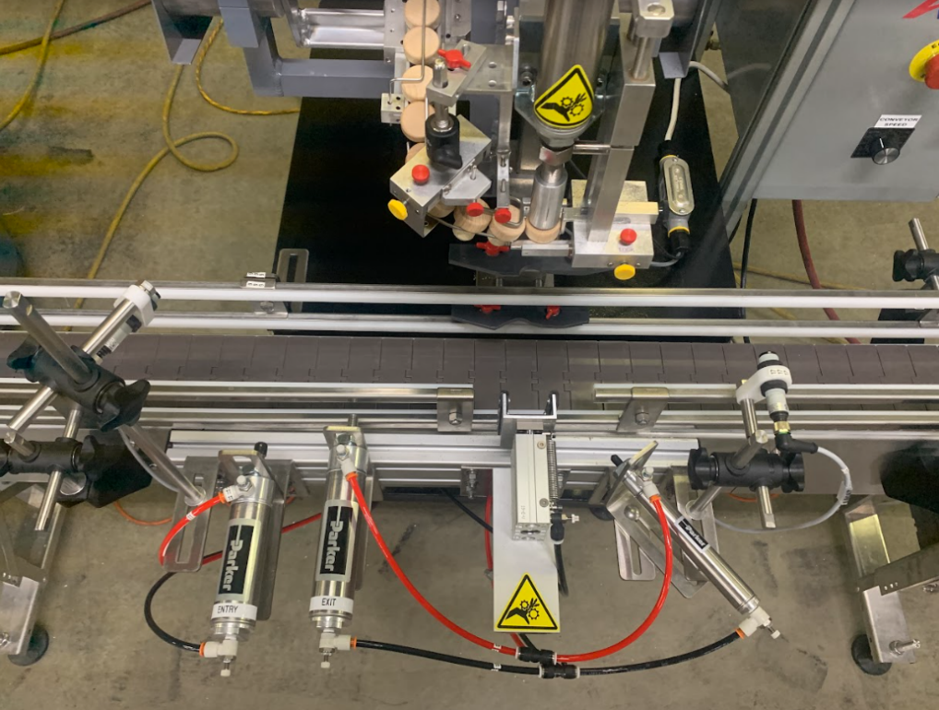

Backup Sensor
Entry Count Sensor

Locator
Cross Blocks

Air Flow Controls
Entry Gate

Exit Gate

Figure 4-7
Guide Rails and Indexing Gates

Figure 4-7 shows a typical (left-to-right) set up of guide rails and indexing gates.

Containers are situated in the fill area by the Entry Gate and Exit Gate locations. The gates or pins, are mounted in place with L-brackets mounted to a sliding mount rail as shown, and are positioned and locked into place with standard nuts and bolts.

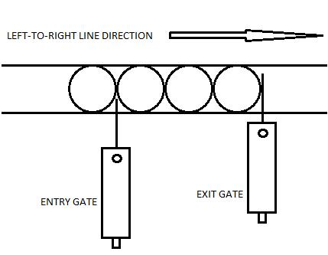
The exit gate is set so that it extends over more than half of the container diameter, so the containers are positively stopped during the indexing cycle. The entry gate only extends far enough to hold back incoming containers from moving past it, without affecting their position when extended, as shown in Figure 4-8. The T-Corker, however, will only have one bottle between the entry and exit gates.

Air cylinders are typically equipped with air flow control valves to adjust the speed which the cylinders will operate. Turn clockwise to slow the extension or retraction, counter-clockwise to speed.
Figure 4-8
Entry and Exit Gate Setup

4.5 CONTAINER SENSOR ADJUSTMENTS AND LOCATIONS

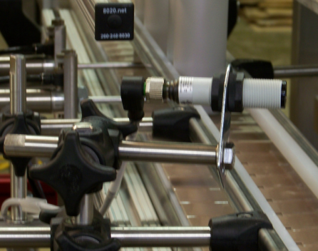
Sensors are positioned along the container path on the conveyor (such as shown in Figure 4-9) to count and/or verify the container position. A variety of sensors can be utilized, depending upon the type of container to be sensed (clear glass, plastic bottle, metal can, etc.) Sensors located prior to the cycle area count the proper number of containers entering the cycle area and verify sufficient containers are available prior to the cycle area. Sensors located downstream from the cycle area will sense if a backup has occurred, and will pause the cycle operation until the backup or jam has cleared.
Figure 4-9
Typical Container Sensor

5.1 CONTROL PANEL

5.2 MAIN CONTROL SCREEN

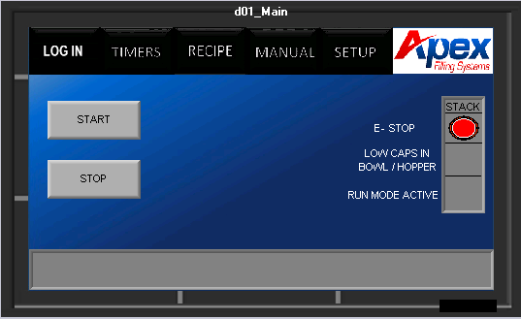

Figure 5-1
Main Page

On the left of Figure 5-1, The operator can start and stop the cycle. On the right you have a virtual stack light to match physical stack light optional. Along the top you can enter Log in, Timers, Recipes, Manual or setup screens.

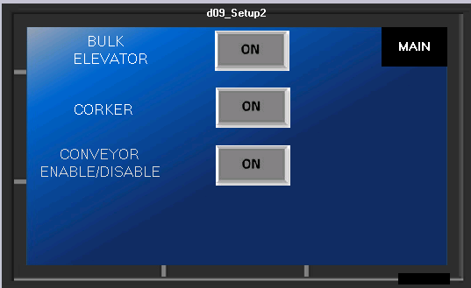
5.3 SETUP PAGE

Figure 5-2
Setup Page

As shown in Figure 5-2, The operator can select which functions they would like to utilize or not.

5.4 INPUT/OUTPUT PAGE
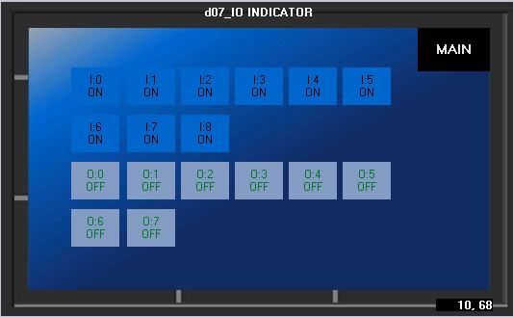

Figure 5-3
Input / Output Page

In the I/O (Input / Output) page, shown in Figure 5-3, technically trained operators have the ability to alter inputs and outputs of the machine. This page should not be altered without prior technical experience

5.5 TIMERS PAGE

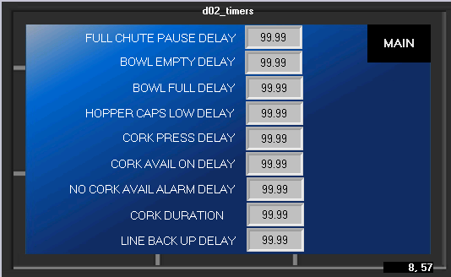

Figure 5-4
Timers

Full chute Pause Delay: How long after upper chute fiber is met that the sorting bowl pauses

Bowl Empty Delay: How long after bowl level sensor reads low the bulk elevator turns on

Bowl Full Delay: How long after Bowl level sensor reads full that the bulk elevator turns off

Hopper Caps Low Delay: How long after the bulk elevator hopper sensor reads low before alarming

Cork Press Delay: How long after the bottle sensor reads a container or the indexing is complete that the cork is inserted

Cork Avail On Delay: How long after cork avail fiber is made before continuing corking.

No Cork Avail Alarm delay: How long does the cork avail need to be not met before setting alarm

Cork Duration: How long does the corker press for once activated

Line backup delay: How long should line backup be blocked before alarm

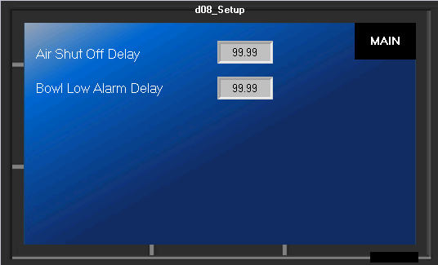

Figure 5-5
Second Timers Page

Behind The maintenance log in screen, you will find these two isolated timers

Air shutoff Delay: How long will air run after Sorting motor stops

Bowl Low Alarm Delay: How long after Bowl reads low until Alarm and Pause

5.6 Manual Page

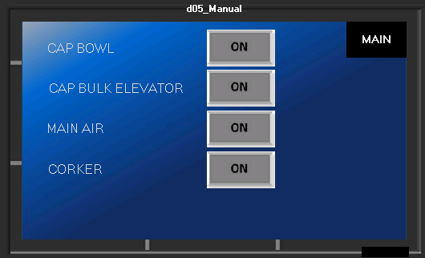

On the manual page users can operate many functions for setup or diagnosis by pressing any button with the named function.

5.7 ASU

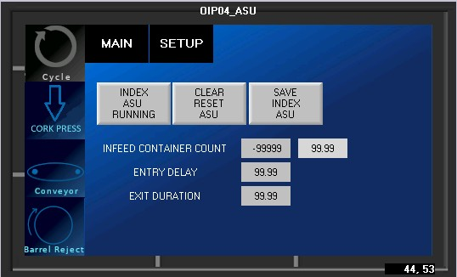

Basic sequence of ASU indexing setup (pin indexing):

    - Ensure the entry and exit gates are properly aligned in the cork area and the guide rails are set properly
    - Ensure the count eye is accurately reading containers
    - Set up sufficient containers to fill the cork area plus any additional containers necessary to reach the count eye
    - The containers should be set up-stream from the entry gate, and the cork area should be clear of containers
    - Press START ASU INDEX to activate the conveyor, the entry gate will open, and the count eye will read the containers
    - When the count eye has read the proper number of containers, the indexing ASU has finished
    - Press SAVE INDEX ASU

5.8 RECIPE

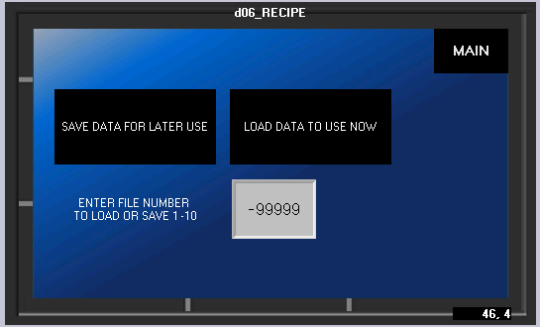

Here you can save your timers and setups by clicking save or load them for use now by pressing load. You will press the numerical box to select a recipe number 1-10.

5.9 LOG IN

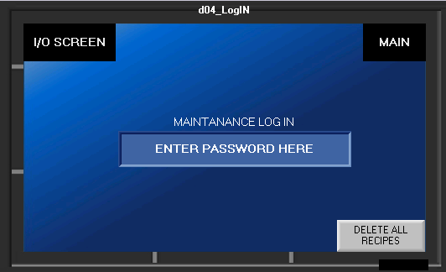

From the log in screen you can clear all recipes, access the IO screen Or log in to the maintenance screen with provided log in sheet to access timers.
6.1 ELECTRICAL

6.2 MAIN CONTROL BOX

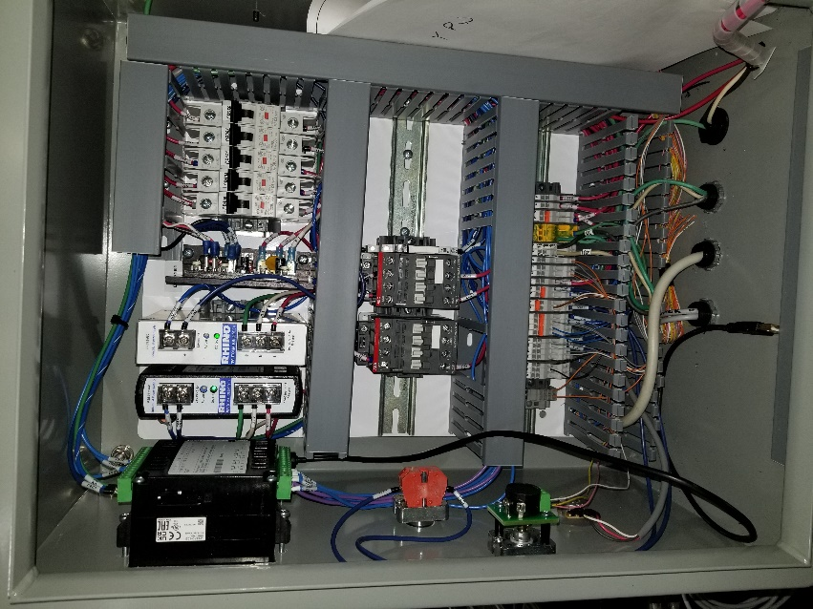
Fuses
Screen and PLC

Power Supply
Emergency Stop

Power Distribution
Speed Potentiometer

Figure 6-1
Main Control Box

A typical T-Corker control box is shown in Figure 6-1. Similar components and layouts will be used, regardless of the actual filler type.

6.3 FRONT PANEL CONTROLS

In addition to an Emergency Stop button and the main Power Reset button/indicator, the front panel operator interface generally provides access to conveyor speed potentiometer as well.

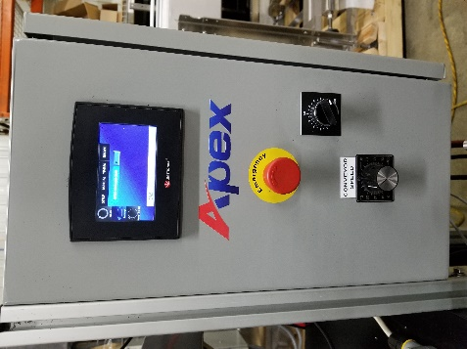

E-STOP Sorter Speed

Potentiometer

Conveyor Speed

Potentiometer

Figure 6-2
Front Panel Controls

6.4 AIR SOLENOIDS

Air solenoids, typically mounted to the side, or rear, of the main control box, provide pneumatic logic control for the machine operation. An electrical signal, sent from the PLC, activates the solenoid attached to the air valve, switching the air pressure from one port to the other, extending or retracting the connected air cylinder (indexing gates, dive cylinder, drip tray cylinder, etc)

Solenoids may be manually activated by pressing the orange button located on the face of the solenoid assembly to assist with troubleshooting.

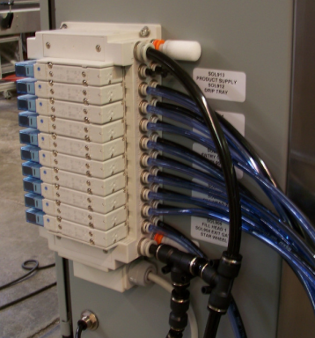

Figure 6-3

Air Solenoids

7.1 | TROUBLESHOOTING
7.2 | GENERAL TROUBLESHOOTING
SYMPTOMS |  | POSSIBLE RESOLUTIONS
 |  | Verify inlet power is active
 | Machine does not power-up
 | Machine does not power-up | Verify Main Disconnect is rotated to ON
 |  | Check Main Fuses or Circuit Breakers
 |  | Verify that machine is properly setup.
 |  | See section 4.
 | Machine is not Corking or Sorting | Verify sufficient air pressure is available
 |  | Verify the barrel speed and rejection system
 |  | are adjusted properly

8.1 SERVICING

8.2 CLEANING PROCEDURE

It is important that the machine is kept clean of dirt, broken glass, sand, etc. as these will reduce the wear life of the air cylinders, contact parts, pump seals, o-rings, etc. The machine should be cleaned with water or soap at regular intervals. Stronger detergents are often used in the food industry and can be corrosive on the machine components. Therefore, the machine should be washed down thoroughly immediately after cleaning with any harsh detergents.


WARNING: When using a high-pressure pistol with cold and hot water, or steam for cleaning, do not spray near any electrical enclosures.

If the machine is to sit dormant for more than 48 hours (or less, depending upon the product) it is good practice to completely clean the product lines, pumps, fill heads, contact parts, etc. If solvent is needed to dissolve product effectively, it is equally important to flush with clean water after cleaning product residue. Harsh detergents and solvents can harm seals and tubing and should be cleared from the system.

Components | Daily | Weekly | Quarterly
Wipe down T-Cork contact parts | x
Visually inspect the machine for any leaks or damaged parts. | x
Wipe down air cylinder rods to help with wear on the seals |  | x
Inspect any seals on the machine for wear. |  | x
Check air solenoids for proper functioning. |  |  | x
Visually inspect electrical box and all electrical components for wear. |  |  | x

9.1 FACTORY CONTACT INFORMATION

9.2 CONTACT APEX DIRECTLY

Apex Filling Systems, LLC
1001 Eastwood Road | Spare Parts
1001 Eastwood Road | Direct: 1-219-402-0211
Michigan City, Indiana 46360 USA | Direct: 1-219-402-0211
Michigan City, Indiana 46360 USA | Service  Direct: 1-219-363-5463
(219) 575-7493 | Service  Direct: 1-219-363-5463
www.apexfilling.com

NOTES

