Tabletop Piston Filler pneumatics explanation and common issues
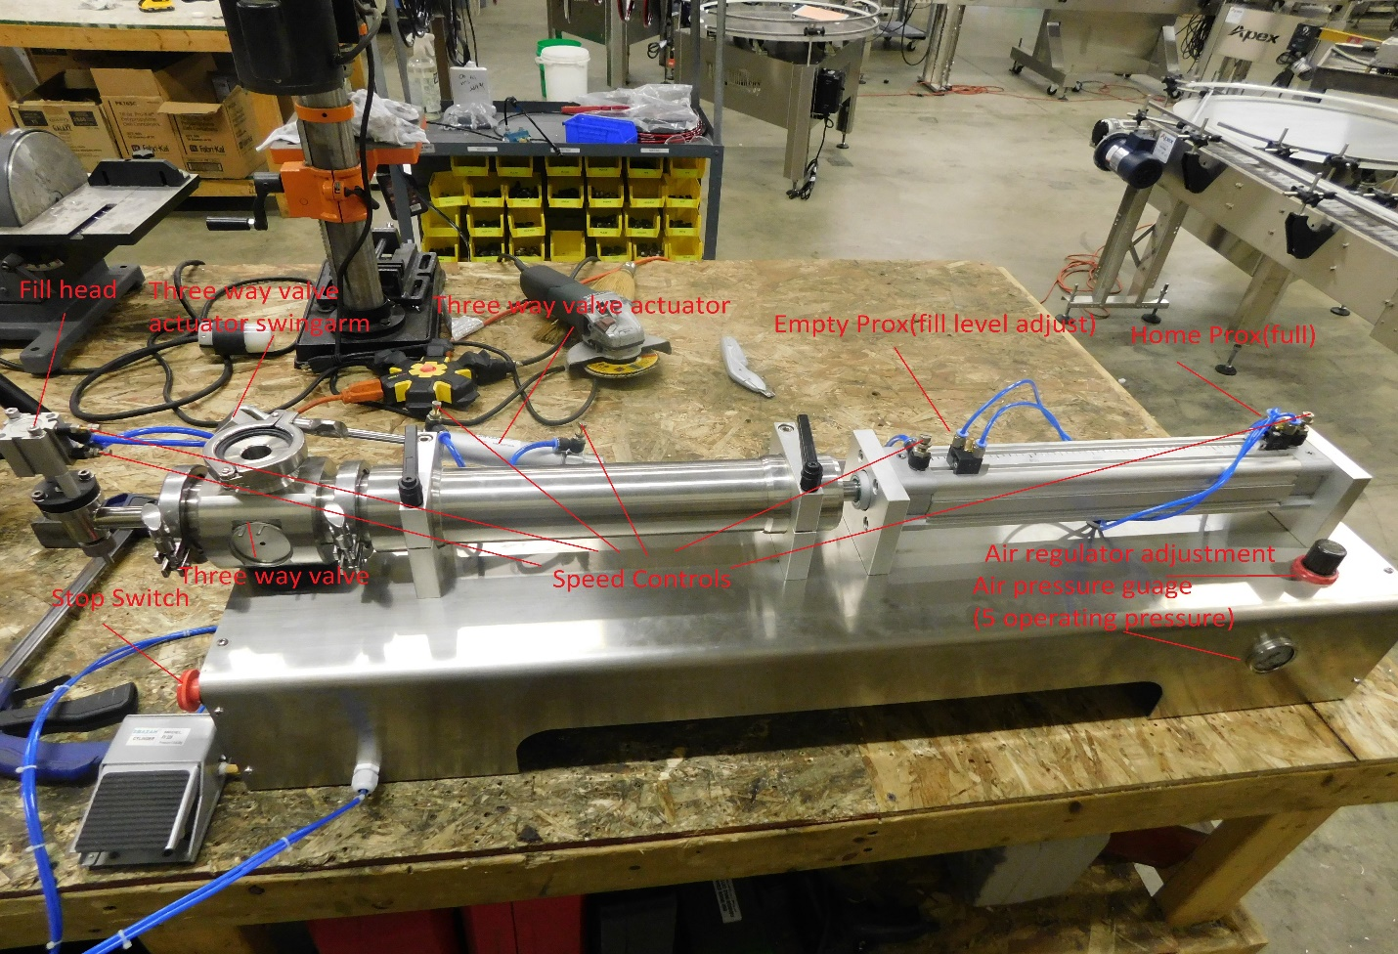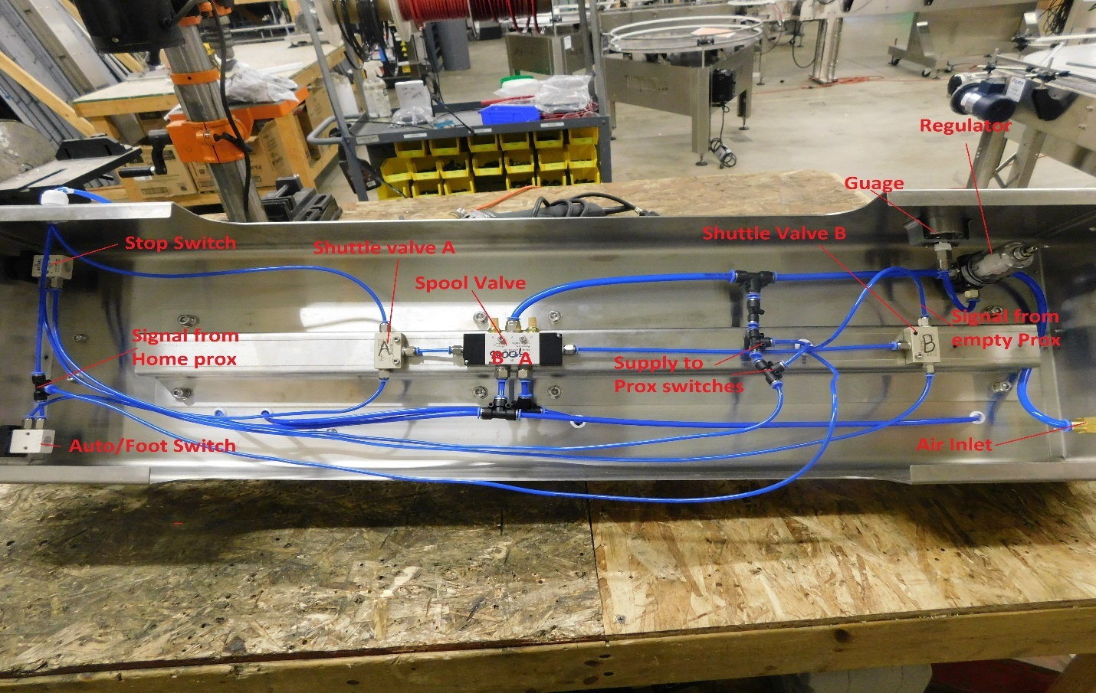

At rest, Stop pulled out air supplied will flow to regulator, gauge, home and empty prox, P port on E stop and P port on spool valve.
With product piston at the home position and prox made (indicator should be up), air will flow thru the prox and supply air to the IN port on the foot pedal and the P port on the auto/Foot switch.
At this position air should be flowing thru the spool valve from the P port out the A port to the front of the product supply cylinder holding it at the home position.
When operating in foot mode you would then press the foot pedal which would pass a blast of air supplied from the home switch to the top of Shuttle valve A passing thru and into the side port of the spool valve shifting the spool now allowing air from the P port on the spool to pass thru to the B port which then supplies air to the bottom of the product supply cylinder driving it toward the empty prox. Once you let off the pedal the air from the pedal switch to the spool valve side port should exhaust from the vent on the pedal.
When the product cylinder moves to your empty (fill level adjustment) prox position it will read and the green indicator will pop up, this will also allow a blast of air to pass thru the prox and into the top of the shuttle valve B which allows air to flow thru to the side port on the spool valve shifting the spool and allowing air to now move from the P port on the spool to the A port now again supplying the top of the product cylinder driving it toward the home position. When the cylinder leaves the empty prox the indicator will pull back in and air will not be able to travel thru the prox and will exhaust thru the vent on the prox switch.
During automatic mode Starting at the home position at rest, the auto/foot switch is rotated to auto. When the switch is rotated it allows air passing thru the home prox to pass thru the p port on the auto/foot switch and into the bottom of shuttle valve A where it passes thru and out the side port into the side port of the spool valve shifting the spool and allowing air to pass thru the P port of the spool out the B port and into the home side of the product cylinder driving it toward the empty prox, once the product cyl leaves the home position the home prox will not be made indicator should pull in and air will not pass thru the prox, air in the line supplying the spool will be exhausted from the prox switch. When the product cyl reaches the empty switch (fill level adjustment) the indicator will pop up allowing air to pass thru the prox and into shuttle valve B top port and passes thru into the side port of spool valve shifting spool back and allowing air to pass from P port on spool valve to Port A and out to the top or empty side of product cylinder driving it toward the home prox. When the product cyl leaves the empty switch, the indicator will pull in and air will not be able to flow thru the prox and air supplying the spool valve will be vented out of the empty prox vent.
When stop button is pressed supplied air is allowed to pass thru the stop switch and into shuttle valve B bottom port and out side port into side port of spool valve sliding spool allowing air to flow from spool valve P port out spool valve A port and supplying air to the empty or top side of product cylinder driving it to the home position.

Common issues
Air lines swapped on pedal
Air fittings are labeled IN and Out on pedal and must be setup with incoming air from Home prox going inti IN port and out port line going to shuttle valve A top port. If these are swapped you will have air bleeding from vent on pedal at rest. Air will still be allowed to pass thru pedal when pushed but when released the air within the line between pedal and spool valve will remain slightly pressurized as it cannot vent from pedal vent. This will cause a rapid short cycle of the machine after it reaches the empty switch due to the empty switch being met and then sending a signal to the spool valve to shift which overcomes the residual air pressure on shuttle valve A circuit temporarily shifting the spool until the prox closes and then the residual air shifts the spool back forcing the product cyl back again toward the empty switch and so on, you will notice the green indicator on the empty prox cycling in and out.
Cylinder does not move when pedal pressed or auto switched on
A common problem here is the home prox being moved and now not reading. When you have air on the machine and press the stop button the machine should force the product cylinder to the home position side of cylinder all the way. To verify this open both speed controls on product cylinder and press the stop switch, watch the piston in the product barrel and verify it comes all the way back in the bore and then loosen the home prox ( can be verified as it will have one airline supplied from the regulated air line into machine one of two T fittings of 3/8 air line and other air line comes from prox to the top fitting of shuttle valve B) and slide this prox toward the base of the product cylinder. When you reach the base of the piston the green indicator should pop out on the prox switch, you should be very near the end of the slot the prox rides in, you can lock the prox down here.
Cylinder does not move when pedal pressed/auto switched on or extends fully and stops never retracting until stop button is pressed.
These are fairly easy to check on the machine. Each prox switch should have two air lines, one line on each prox will be supplied with air as soon as you hook up your air supply on the outside of the machine. The opposite air line on the prox switch will only be supplied with air when the prox switch has read the steel piston inside the product cylinder and opens, this will be indicated by a green indicator popping out next to the air fittings. Verify the product cylinder is at the home position and then verify which air line is supplied constant air pressure on the prox switch by looking under the machine and locating the two T fittings just after the regulator, each T fitting supplies one prox switch so follow these lines up to each prox and remove at the prox verifying air pressure is present(be careful as you remove the air line from the push connect as it should have air coming from it). Once you verify you have supplied air pressure to each prox remove the opposite air line from the supplied pressure line you removed previously. There is a small green indicator on top of the prox next to the air line fittings that should pop out when the switch is reading the steel piston within the product supply cylinder, you can loosen the prox switch and slide it toward the home side of the product cylinder when it reaches the end of the slot you should read the steel piston within the product supply cylinder and the green indicator should pop out and you should get a blast of air from the open fitting you removed the air line from, when you move it back off of the piston the indicator should drop back in and you should no longer have air coming from the fitting. Check both prox switches this way and make sure if both prox switches are in the same track you remove the fill level adjustment switch and slide it down a different track on product cylinder so as you can reach the base of the piston bore without contacting the opposite prox switch. Be sure to reset home prox if moved under proper procedure. When you have air on the machine and press the stop button the machine should force the product cylinder to the home position side of cylinder all the way. To verify this open both speed controls on product cylinder and press the stop switch, watch the piston in the product barrel and verify it comes all the way back in the bore and then loosen the home prox ( can be verified as it will have one airline supplied from the regulated airline into machine one of two T fittings of 3/8 airline and other airline comes from prox to the top fitting of shuttle valve B) and slide this prox toward the base of the product cylinder. When you reach the base of the piston the green indicator should pop out on the prox switch, you should be very near the end of the slot the prox rides in, you can lock the prox down here.
Cylinder will not cycle but prox test fine or cyl will not home with stop.
This could be an issue with a stuck spool valve, this is easily tested on the machine. Flip the machine on its side and clamp to table. Remove air lines from ports A and B on bottom of spool noting location. Remove air lines from both side ports and connect supply air. Use an air nozzle and apply air pressure in one side port and then the other as you alternate sides you should have air exiting the spool valve from port A or port B one or the other as you apply pressure to one side of the spool. If you have air coming from both ports at once or if the air flow does not change from A to B or B to A when air is applied to side ports then the spool valve is bad and needs replaced.

