

Eco ROPP Operations Manual

V1.4

TABLE OF CONTENTS
- SAFETY Page
  - GENERAL SAFETY 3
  - ELECTRICAL SHOCK 3
  - CONTACT MATERIALS COMPATIBILITY 3
  - SAFETY COMPLIANCE LIABILITY 4
  - CONVENTIONS 4
- MACHINE FEATURES & SPECIFICATIONS
  - INTRODUCTION 5
  - FEATURES & BENEFITS 5
  - UTILITY REQUIREMENTS 5
- INSTALLATION & START-UP
  - INSTALLATION PROCEDURES 6
  - START-UP & COMMISSIONING 6
- MECHANICAL ADJUSTMENTS
  - THEORY OF OPERATION 8
  - ROPP CAPPER COMPONENT OVERVIEW 9
  - CONTAINER GUIDE RAIL 10
  - CONTAINER SENSOR ADJUSTMENTS AND LOCATIONS 11
  - ROPP HEAD HEIGHT ADJUST 11
  - CAP CHUTE
  - POCKET SORTER 11
  - FRONT PANEL CONTROLS 14
  - AIR SOLENOIDS 14

- OPERATOR INTERFACE SCREENS
  - MAIN CONTROL SCREEN 15
  - Setup SCREEN 16
  - Timers SCREEN 1 17
  - timers SCREEN 2 18
  - Manual SCREEN 19
  - I/O SCREEN 20
  - Recipe SCREEN 21
  - LoGIN SCREEN 22

- TROUBLESHOOTING
  - GENERAL TROUBLESHOOTING 23
- SERVICING
  - CLEANING PROCEDURE 24
- FACTORY CONTACT INFORMATION
  - CONTACT APEX DIRECTLY 24

SAFETY
  - GENERAL SAFETY
Apex Filling Systems, LLC (APEX) manufactures and designs all of its products so they can be operated safely. However the primary responsibility for safety rests with those who use and maintain these products. The following safety precautions are offered as a guide that if conscientiously followed, will minimize the possibility of accidents throughout the useful life of this equipment. The safety of personnel, equipment and plant facilities should be considered during equipment operation and with each changeover of product, or any machine modifications.

Only those who have been trained and delegated to do so and have read and understood this operator's manual should operate the equipment. Failure to follow the instructions, procedures and safety precautions in this manual can result in accidents and injuries.

DO NOT modify the equipment except with written factory approval. Unauthorized equipment modifications will void the warranty.

Each day walk around the equipment and inspect for leaks, loose parts, missing or damaged components, and parts out of adjustment. Perform all recommended maintenance noted in this manual.

EQUIPMENT SHOULD ALWAYS BE DE-ENERGIZED (POWER AND AIR) BEFORE MAKING MECHANICAL ADJUSTMENTS.

  - ELECTRICAL SHOCK
- To avoid electrical shock hazard, make sure this equipment is properly grounded.
- Dangerous voltages are present within the electrical enclosures. DO NOT operate this equipment with electrical covers open or removed.
- Keep all parts of the body, hand held tools, or other conductive objects away from exposed live-parts of the electrical system. Maintain dry footing and stand on insulating surfaces. DO NOT contact any portion of the equipment when adjusting or making repair to exposed live parts of electrical system.
- Attempt repairs only in a clean, dry, well-lighted, and ventilated area.

  - CONTACT MATERIALS COMPATIBILITY
APEX endeavors to make all contact parts compatible with buyer's products, if known. Because of the wide variety of possible products, Apex Filling Systems, LLC cannot be responsible or liable for ensuring compatibility of contact material with the products. Evaluate material compatibility prior to machine use. Failure to follow this procedure can result in machine damage, fire, operator injury or death

  - SAFETY COMPLIANCE LIABILITY
APEX endeavors to make machinery as safe to operate as possible. National, state and local laws related to safety in the workplace apply primarily to the responsibilities of the employer, and not the equipment manufacturer. The seller agrees to cooperate with the buyer in finding feasible answers to compliance problems. However, because APEX has little control of the many factors which may significantly affect the environment in which this equipment is installed, the seller does not warrant this equipment to be in compliance with OSHA or any like state or local laws or regulations. It is the buyer's responsibility to provide the modifications necessary to assure compliance with the laws and regulations at the point of installation.
A complete inspection of product is necessary until the machinery is proven to produce acceptable results. This should also be performed after every changeover.

  - CONVENTIONS
To ensure the safety of personnel which will install, adjust, maintain and operate this equipment, it is imperative that they understand the dangers, warnings and caution notices. It is important to understand the signal words that may be used throughout this manual.

 | Alerts to immediate hazard, which will result in death or severe personal injury, if not avoided
 | Alerts to a hazard which will result in serious injury, or death in some cases, if not avoided.
 | Alerts to a potential hazard that may result in a serious personal injury, if not avoided. It also alerts against an unsafe practice that will permanently damage equipment or property.
 | Indicates a suggestion as to how to use or adjust the equipment for best product results.
 | Points out a proper use that will avoid damage to the equipment, or will extend the life of the parts.

MACHINE FEATURES & SPECIFICATIONS
  - INTRODUCTION
APEX machines are designed to be easy to setup and maintain, capable of providing years of reliable service. Versatile by design, APEX fillers can accommodate a wide variety of product and container configurations, often without the need for change parts. Modular design allows for fully automatic or semi-automatic systems. Tool-less adjustments are available, and allow for easy and quick changeover for various product and container combinations. Operator controls are easily accessed via the front panel of the unit.
  - FEATURES & BENEFITS
- Easy Changeover
Simple mechanical adjustment for different bottle sizes. Quick to changeover, simple to use and easy to clean
- Robust
Anodized aluminum and stainless steel shells, frames, legs and housings maximize the working life of your machine, and minimize maintenance costs and downtime
- Customizable
Whatever the production need, APEX has a design to meet
- Flexible
Versatility and Simplicity are intrinsic to the design. Many container sizes and shapes, and many products can be run on one machine
  - UTILITY REQUIREMENTS
Compressed Air Consumption: Clean, dry (non-oiled) compressed air 80-100psi /
up to 20cfm depending on options
Refer to machine specific documentation.
Electrical Consumption: 220VAC / 60Hz / Single Phase / 20A depending on options
Alternate electrical supply configurations are possible.
Refer to machine specific documentation.

INSTALLATION & START-UP
  - INSTALLATION PROCEDURES
The capper assembly should be placed on a solid, level foundation. The main frame should be leveled using threaded leveling pads or other suitable means to secure the equipment in place. Electrical connections should be properly terminated into the main electrical enclosure by properly trained technicians, and appropriate supply voltage, proper phase and adequate supply amperage should be verified prior to powering up the equipment. Sufficient compressed air should be available and connected for proper operation.

  - START-UP & COMMISSIONING

This manual should be read completely before powering-up the machine. Commissioning of the machine should be performed by a trained technician only after complete understanding of the machine, and with products that match samples indicated to APEX if supplied. After the machine is adjusted for the bottle and product combination, the machine can be put into operation with the following steps.
Figure 3-1
Emergency Stop
- Check the machine to see that guards are in place
- Check the mechanical system for loose or missing parts
- Ensure the E-STOP button is depressed, and the unit is clear of personnel.
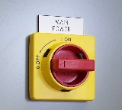
Figure 3-2
Main Disconnect

- Remove any lock-out/tag-out devices and rotate the main power disconnect clockwise to ON
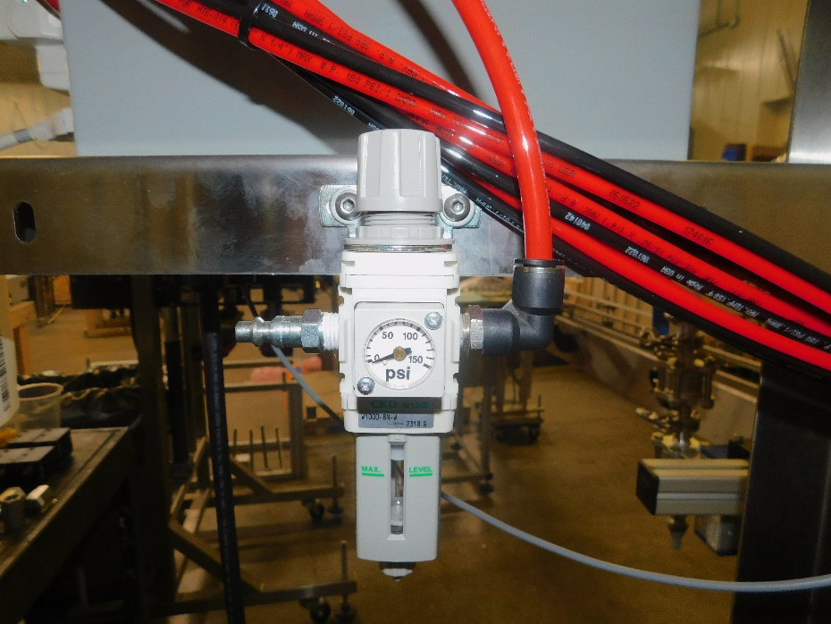
Figure 3-3
Main Air Filter Regulator

Quick Disconnect Air Inlet
Pressure Adjustment Knob
Pressure Indicator Gauge
Air Filter Particulate and Condensate Trap

Keeping clear of any moving parts and assemblies, remove any lock-out/tag-out devices and rotate the main air disconnect clockwise to ON

- Verify that sufficient containers and caps to be used are available to be supplied to the capper
- On the operator interface, press Cycle Start (or equivalent, depending upon controller configuration) to begin the container indexing and capping cycle.
- If capping operations are incorrect, or machine indexing does not perform properly, refer to the appropriate mechanical adjustments

MECHANICAL ADJUSTMENTS
  - THEORY OF OPERATION
APEX automatic ROPP Cappers utilize a synchronized container conveying system and an indexing starwheel to move containers through the capping zone. Guide rails align each container into the starwheel pockets for precise positioning. A pocket sorter uses a custom rotating disk to orient unthreaded aluminum caps before feeding them down a cap chute onto passing bottle necks.
Once positioned beneath the capping head, downward top pressure compresses the cap liner to create a primary seal. Rotating thread-forming rollers mold the aluminum shell directly over the bottle's neck threads, while tucking rollers fold the lower skirt under the neck ring to establish a tamper-evident seal. Upon completion of the capping cycle, an automated discharge actuator retracts to pull the bottle clear of the starwheel pocket, returning it smoothly to the exit conveyor.

  - ROPP CAPPER COMPONENT OVERVIEW
POCKET SORTER
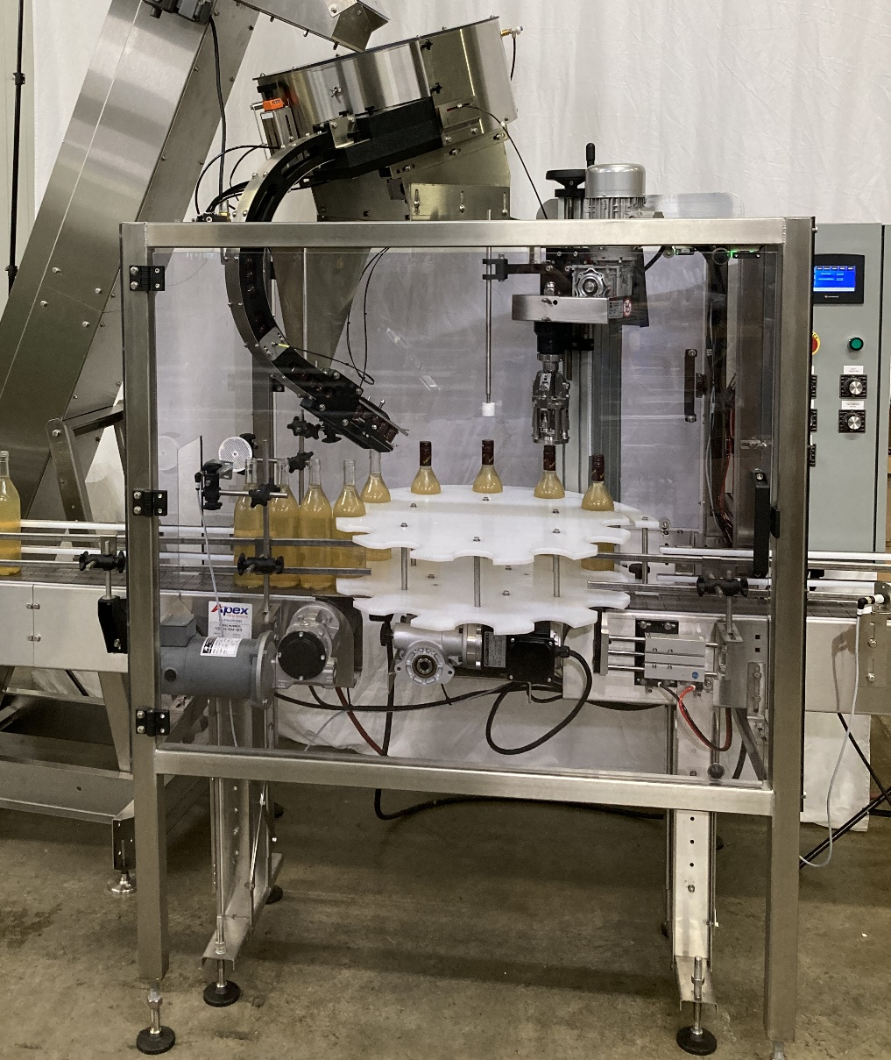
ROPP CAPPER HEAD
STARWHEEL
CONTAINER AVAILABLE SENSOR
INFEED CONVEYOR
CAP CHUTE
FULL CHUTE PAUSE SENSOR
ROPP HEAD HEIGHT ADJUST
STAR WHEEL DISCHARGE ACTUATOR
OPERATOR INTERFACE
FIGURE 4.1
ROPP CAPPER COMPONENT OVERVIEW
ROPP capper configurations vary based on customer-specific application requirements.

  - CONTAINER GUIDE RAILS ADJUSTMENTS
For containers to move properly down the conveyor guide rails must be adjusted so bottles move smoothly. Typically guide rails are set towards the base of the container for best results. Unusual containers may require alternate setups like multiple guide rails or other solutions, to effectively control your specified container. Your guide rails can be adjusted vertically and horizontally via the turnbuckles shown in FIG 4-2
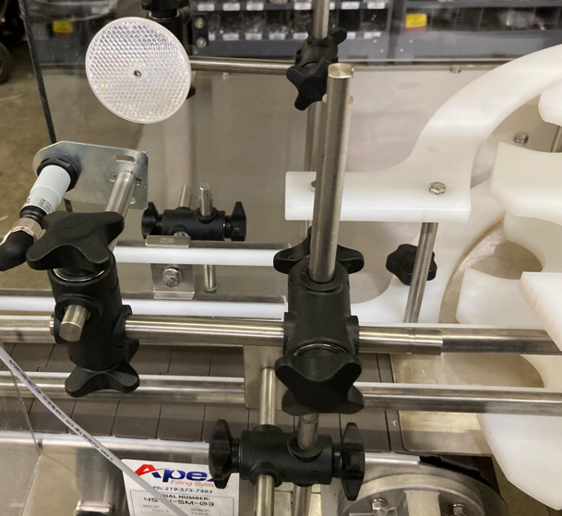
GUIDE RAIL
CONTAINER AVAILABLE SENSOR
CROSSBLOCK

Figure 4-2
Guide Rails and Container Available Sensors

  - CONTAINER AVAILABLE SENSOR ADJUSTMENTS
Sensors are positioned along the container path on the conveyor to count and/or verify the containers position. A variety of sensors can be used depending on the type of container. Sensors located prior to the Star wheel ensure that there is a container in place for the capper to continue its process. Sensors downstream will sense if a backup has occurred and will pause the capping operation until the jam or backup has been cleared. We use the same turnbuckles as the guide rails to make any adjustments quick and easy. Shown in FIG 4-2
  - ROPP HEAD HEIGHT ADJUSTMENT
The ROPP capper Height adjustment is a handle above the ROPP head this can be used to adjust the height of the head for a variety of different containers. Shown in FIG 4-3.
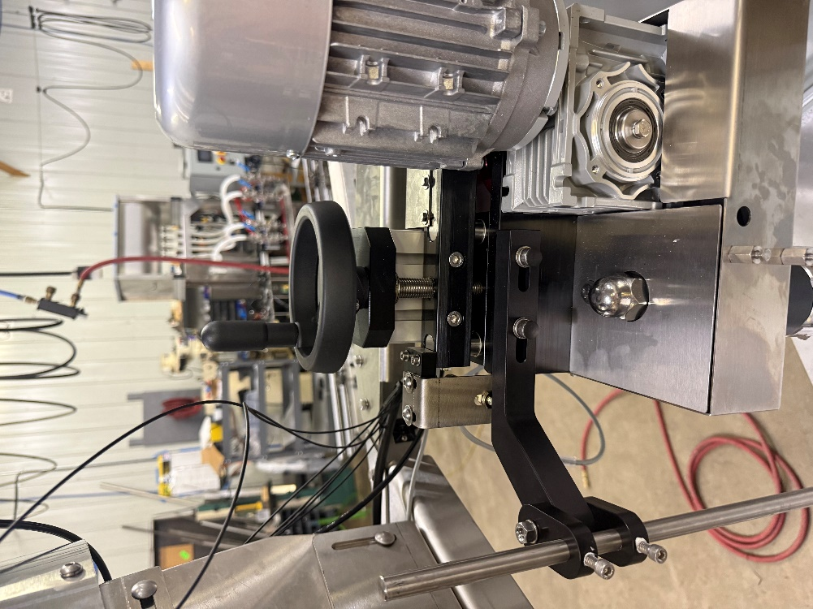
HOME PROX
HEIGHT ADJUST HANDLE
FIG 4-3
Warning Pinch Point

  - Cap Chute / Cap Available Sensor
The custom-made cap chute is used to transfer the orientated cap from the pocket sorter to the bottle neck. While it’s being indexed by the star wheel. It can be adjusted up and down for an assortment of containers. We also have a Cap available sensor at the end of the chute this ensures that the machine will not keep running while you are out of caps. Shown in Figure 4-4 is the full chute pause which helps maintain consistent back pressure of caps.

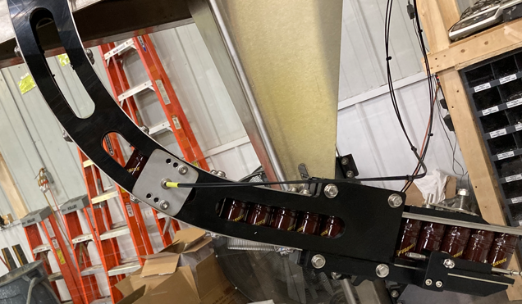
FULL CHUTE PAUSE
FIG 4-4
  - POCKET SORTER
The pocket sorter orientates your caps and feeds them through the chute to the container neck. There is a custom disk inside the pocket sorter made for your cap so we can ensure we feed it onto your bottle correctly. We use keyhole slots to make it very easy for you to change disk quickly. Shown in figure 4-5
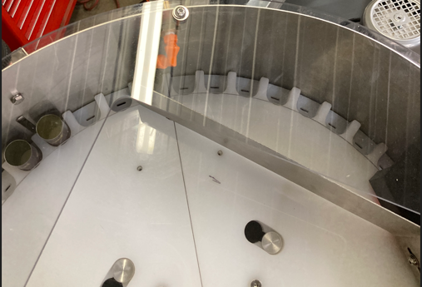
KEYHOLE SLOTS
CAP CHUTE
CAP DEFLECTOR
CUSTOM DISK
FIG 4-5

ELECTRICAL
  - FRONT PANEL CONTROLS
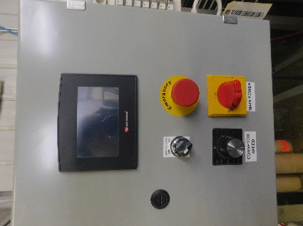
Figure 5-4
Front Panel Controls
Typical controls available to the operator are shown in Fig 5-4
The primary operator interface touch screen, Emergency Stop button, Main Power Disconnect, and Conveyor Controls are generally mounted on the front panel.
Other toggles may be present, depending upon the configuration, please refer to machine specific documentation for custom configurations.

  - AIR SOLENOIDS
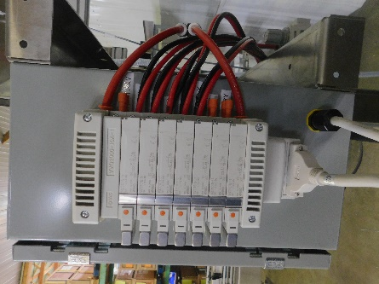
Figure 5-5
Air Solenoids

Air solenoids, typically mounted to the side, or rear, of the main control box, provide pneumatic logic control for the machine operation. An electrical signal, sent from the PLC, activates the solenoid attached to the air valve, switching the air pressure from one port to the other, extending or retracting the connected air cylinder (indexing gates, dive cylinder, drip tray cylinder, etc)
Solenoids may be manually activated by pressing the orange button located on the face of the solenoid assembly to assist with troubleshooting.

OPERATOR INTERFACE SCREENS
  - MAIN CONTROL SCREEN
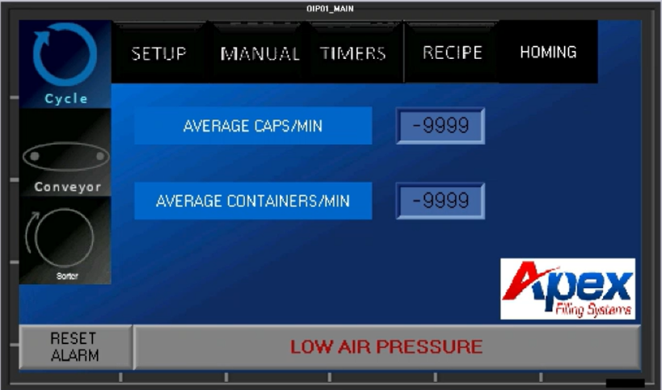
Figure 7-1
Main Screen
From the main control screen, the various sub-screens and timers can be accessed.
Pressing the top buttons (in Fig 7-1 “SETUP, MANUAL, TIMERS, and RECIPE”) will access sub-menus described in the following sections:
SETUP: Section 7.3
TIMERS: Section 7.6, 7.7
MANUAL: Section 7.8
Homing: Section 7.9
RECIPE: Section 7.10
LOGIN: Section 7.11

  - SETUP SCREEN
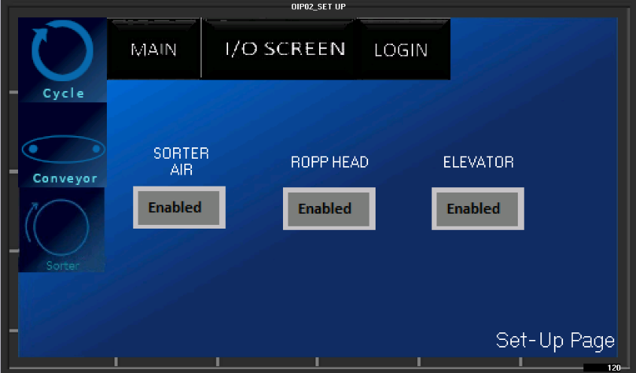
Figure 7-2
Setup screen
- Sorter air: This enables main air to the sorting bowl to flow
- ROPP Head: this enables the capper head
- Elevator: This enables the bulk feeding elevator if equipped

  - TIMERS SCREEN 1
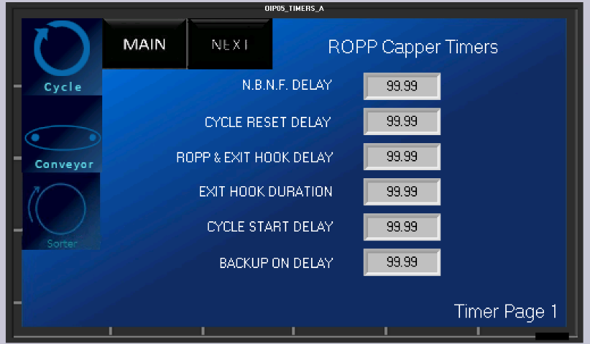
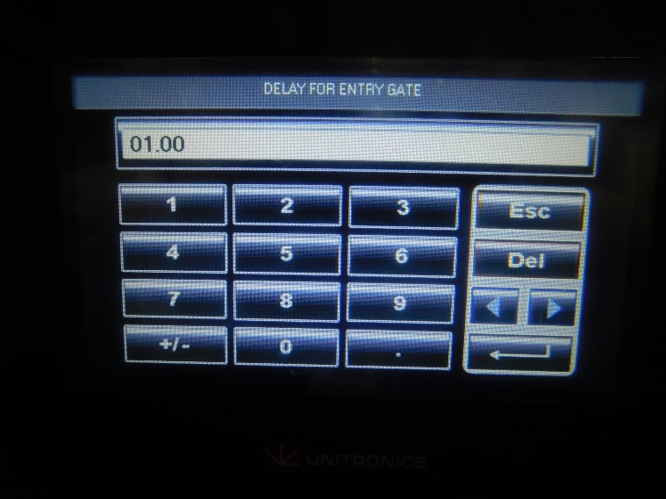
Figure 7-6
Direct Numerical Entry

From this pop-up window, numbers can be directly entered into the program parameters. Pressing ENTER (the lower rightmost button) will save the entry and return to the original screen.
Pressing ESC (the top right button) will return to the original screen without altering the preset count.
NBNF: No bottle no fill timer is the amount of time the count sensor must be blocked after count
Cycle Reset Delay: Delay at end of capping cycle
ROPP & Exit Hook Delay: Delay off these actions after index is complete
Exit Hook Duration: How long the exit hook pushes for
Cycle start delay: Delay in starting cycle once all conditions are met
Back up delay: How long back up sensor is blocked before pausing machine
  - TIMERS SCREEN 2
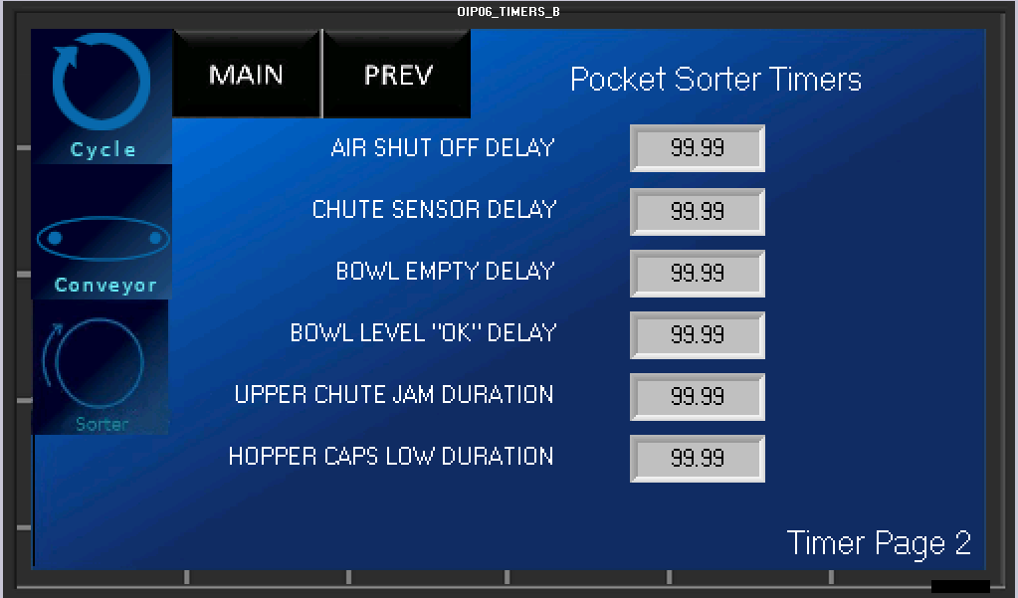

The second Set Timers Screen is functionally equivalent to the first Set Timers Screen.
Air shut off delay: how long after sorting disk stops do we stop airflow
Chute sensor delay: how long after chute is full do we stop the sorter
Bowl empty delay: how long after the bowl is sensed as empty before starting elevator
Bowl level ok delay: After bowl is sensed as full how long until we stop elevator
Upper chute jam duration: how long does the jam sensor detect a cap before we pause
Hopper caps low duration: how long is elevator hopper detected as low before we alarm
  - MANUAL SCREEN
The blue buttons act as toggle switches, activating the associated module:
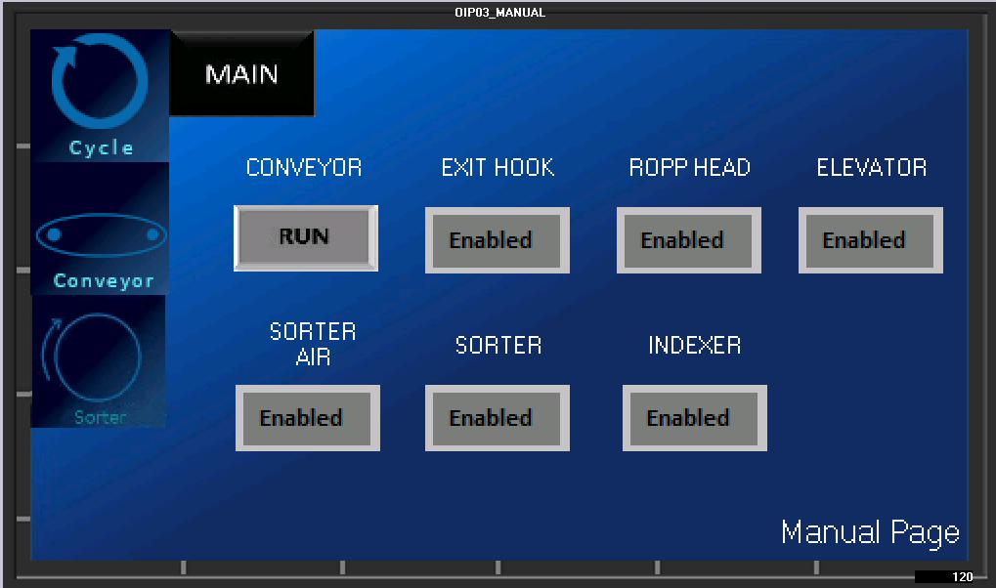

CONVEYOR (AUTO or RUN CONTINUOUS)
Activating this toggle will bypass the conveyor controls, allowing the conveyor to either run for indexing, and stop during Capping (AUTO) or to run continuously (RUN)

Exit Hook
Activating this toggle will actuate the exit hook

ROPP HEAD
Activating this toggle will actuate the ROPP Head

ELEVATOR
Activating will run the bulk elevator

SORTER AIR
Activating Will turn on air to the sorting bowl

SORTER
Activating will run the sorting disk

INDEXER
Activating will run the indexer motor

5.7 I/O SCREEN
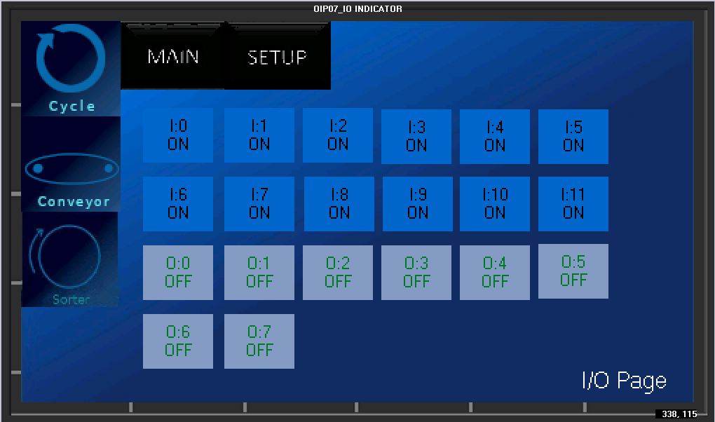

The I/O screen will allow you to view inputs and outputs such as sensors and plc signals to diagnose issues.
  - RECIPE SCREEN
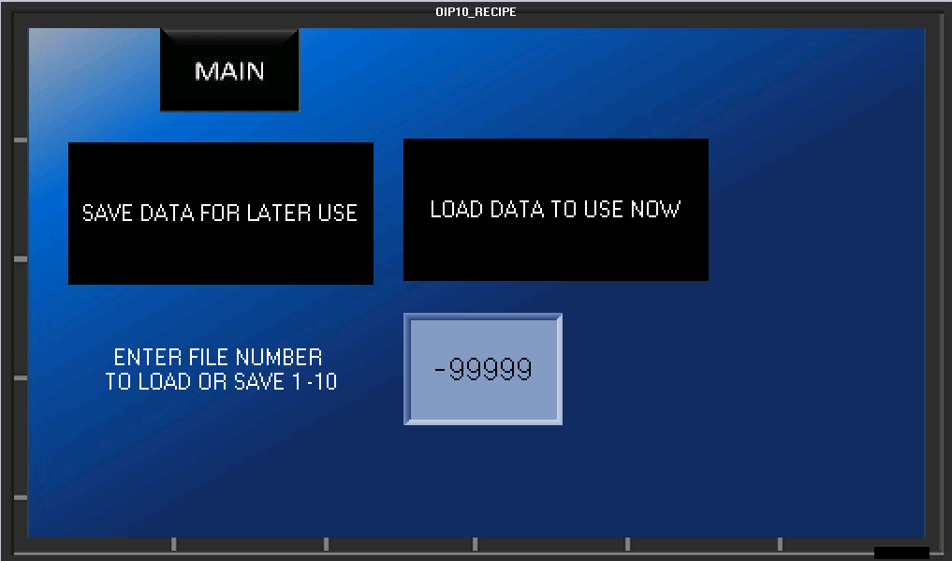
This screen allows the operator to save or load all of the timers which are specific to different containers or setups. Pressing directly on the numeral will pop up the numeric entry window. Press the desired address (1-10) and either save or load the data by pressing the associated button

  - LOGIN SCREEN
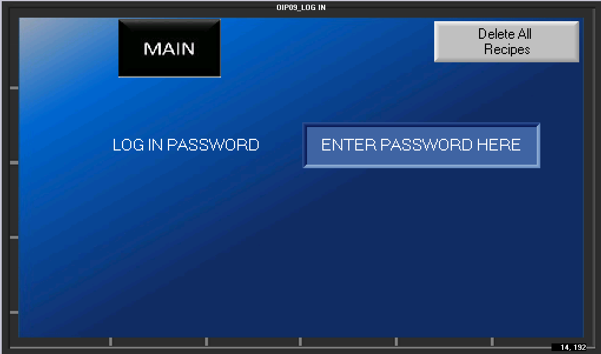

The log in screen will be used for factory setup. On this screen you may also clear all recipes in a factory reset or to clear a recipe corruption state.

TROUBLESHOOTING
6.2 GENERAL TROUBLESHOOTING

SYMPTOMS | POSSIBLE RESOLUTIONS
Machine does not power-up | Verify inlet power is active
Machine does not power-up | Verify Main Disconnect is rotated to ON
Machine does not power-up | Check Main Fuses or Circuit Breakers
Machine does not power-up | Check control transformer (220VAC to 110VAC) and connections
Pocket sorter not sorting | Verify there are no Fault Codes
Pocket sorter not sorting | Verify for Air Pressure
Pocket sorter not sorting | Verify there is no Jams
Pocket sorter not sorting | Verify Pocket sorter motor is running
Unit powers, but will not cycle | Check that the line backup sensor is located properly, and clear of obstruction
Unit powers, but will not cycle | Check the E-Stop is pulled out
Unit powers, but will not cycle | Check that reset power button has been engaged
Specific function inoperable | Verify function is enabled in setup
Specific function inoperable | Verify known good recipe loaded
Specific function inoperable | Check manual switches
Improper Cap Sealing | Verify ROPP head height
Improper Cap Sealing | Inspect forming & tucking rollers for wear or improper adjustment
Improper Cap Sealing | Check Cap chute adjustment
Improper Cap Sealing | Verify Air pressure

SERVICING
CLEANING PROCEDURE
It is important that the machine is kept clean of dirt, broken glass, sand, etc. as these will reduce the wear life of the air cylinders and, o-rings, etc. The machine should be cleaned with water or soap at regular intervals. Stronger detergents are often used in the food industry and can be corrosive on the machine components. Therefore, the machine should be washed down thoroughly immediately after cleaning with any harsh detergents.


WARNING: When using a high-pressure pistol with cold and hot water, or steam for cleaning, do not spray near any electrical enclosures.

FACTORY CONTACT INFORMATION
CONTACT APEX DIRECTLY
Apex Filling Systems, LLC
Spare Parts
Direct: (219) 402-0211
Service: (219) 363-5463
1001 Eastwood Rd
Michigan City, Indiana 46360 USA
(219) 575-7493
www.apexfilling.com
NOTES

