

Eco Pocket Sorter Operations Manual

V1.1

TABLE OF CONTENTS
- SAFETY Page
  - GENERAL SAFETY 3
  - ELECTRICAL SHOCK 3
  - CONTACT MATERIALS COMPATIBILITY 3
  - SAFETY COMPLIANCE LIABILITY 4
  - CONVENTIONS 4
- MACHINE FEATURES & SPECIFICATIONS
  - INTRODUCTION 5
  - FEATURES & BENEFITS 5
  - UTILITY REQUIREMENTS 5
- INSTALLATION & START-UP
  - INSTALLATION PROCEDURES 6
  - START-UP & COMMISSIONING 6
- MECHANICAL ADJUSTMENTS
  - theory of operation 8
- ELECTRICAL
  - FRONT PANEL CONTROLS 9
  - AIR SOLENOIDS 9

- OPERATOR INTERFACE SCREENS
  - MAIN CONTROL SCREEN 10
  - LOG IN 11
  - MANUAL 12
  - Timers SCREEN 13
  - rECIPE 14

- TROUBLESHOOTING
  - GENERAL TROUBLESHOOTING 15
- SERVICING
  - CLEANING PROCEDURE 16
- FACTORY CONTACT INFORMATION
  - CONTACT APEX DIRECTLY 16

SAFETY
  - GENERAL SAFETY
Apex Filling Systems, LLC (APEX) manufactures and designs all of its products so they can be operated safely. However the primary responsibility for safety rests with those who use and maintain these products. The following safety precautions are offered as a guide that if conscientiously followed, will minimize the possibility of accidents throughout the useful life of this equipment. The safety of personnel, equipment and plant facilities should be considered during equipment operation and with each changeover of product, or any machine modifications.

Only those who have been trained and delegated to do so and have read and understood this operator's manual should operate the equipment. Failure to follow the instructions, procedures and safety precautions in this manual can result in accidents and injuries.

DO NOT modify the equipment except with written factory approval. Unauthorized equipment modifications will void the warranty.

Each day walk around the equipment and inspect for leaks, loose parts, missing or damaged components, and parts out of adjustment. Perform all recommended maintenance noted in this manual.

EQUIPMENT SHOULD ALWAYS BE DE-ENERGIZED (POWER AND AIR) BEFORE MAKING MECHANICAL ADJUSTMENTS.

  - ELECTRICAL SHOCK
- To avoid electrical shock hazard, make sure this equipment is properly grounded.
- Dangerous voltages are present within the electrical enclosures. DO NOT operate this equipment with electrical covers open or removed.
- Keep all parts of the body, hand held tools, or other conductive objects away from exposed live-parts of the electrical system. Maintain dry footing and stand on insulating surfaces. DO NOT contact any portion of the equipment when adjusting or making repair to exposed live parts of electrical system.
- Attempt repairs only in a clean, dry, well-lighted, and ventilated area.

  - CONTACT MATERIALS COMPATIBILITY
APEX endeavors to make all contact parts compatible with buyer's products, if known. Because of the wide variety of possible products, Apex Filling Systems, LLC cannot be responsible or liable for ensuring compatibility of contact material with the products. Evaluate material compatibility prior to machine use. Failure to follow this procedure can result in machine damage, fire, operator injury or death

  - SAFETY COMPLIANCE LIABILITY
APEX endeavors to make machinery as safe to operate as possible. National, state and local laws related to safety in the workplace apply primarily to the responsibilities of the employer, and not the equipment manufacturer. The seller agrees to cooperate with the buyer in finding feasible answers to compliance problems. However, because APEX has little control of the many factors which may significantly affect the environment in which this equipment is installed, the seller does not warrant this equipment to be in compliance with OSHA or any like state or local laws or regulations. It is the buyer's responsibility to provide the modifications necessary to assure compliance with the laws and regulations at the point of installation.
A complete inspection of product is necessary until the machinery is proven to produce acceptable results. This should also be performed after every changeover.

  - CONVENTIONS
To ensure the safety of personnel which will install, adjust, maintain and operate this equipment, it is imperative that they understand the dangers, warnings and caution notices. It is important to understand the signal words that may be used throughout this manual.

 | Alerts to immediate hazard, which will result in death or severe personal injury, if not avoided
 | Alerts to a hazard which will result in serious injury, or death in some cases, if not avoided.
 | Alerts to a potential hazard that may result in a serious personal injury, if not avoided. It also alerts against an unsafe practice that will permanently damage equipment or property.
 | Indicates a suggestion as to how to use or adjust the equipment for best product results.
 | Points out a proper use that will avoid damage to the equipment, or will extend the life of the parts.

MACHINE FEATURES & SPECIFICATIONS
  - INTRODUCTION
APEX machines are designed to be easy to setup and maintain, capable of providing years of reliable service. Tool-less adjustments are available, and allow for easy and quick changeover for various product and container combinations. Operator controls are easily accessed via the front panel of the unit.
  - FEATURES & BENEFITS
- Easy Changeover
Simple mechanical adjustment for different bottle sizes. Quick to changeover, simple to use and easy to clean
- Robust
Anodized aluminum and stainless steel shells, frames, legs and housings maximize the working life of your machine, and minimize maintenance costs and downtime
- Customizable
Whatever the production need, APEX has a design to meet
- Flexible
Versatility and Simplicity are intrinsic to the design. Many container sizes and shapes, and many products can be run on one machine
  - UTILITY REQUIREMENTS
Compressed Air Consumption: Clean, dry (non-oiled) compressed air 90-100psi /
up to 20cfm depending on options
Refer to machine specific documentation.
Electrical Consumption: 110VAC / 60Hz / Single Phase / 20A depending on options
Alternate electrical supply configurations are possible.
Refer to machine specific documentation.

INSTALLATION & START-UP
  - INSTALLATION PROCEDURES
The assembly should be placed on a solid, level foundation, with the chute aligned with main feed inlet of capping machine. Electrical connections should be properly terminated into the main electrical enclosure by properly trained technicians, and appropriate supply voltage, proper phase and adequate supply amperage should be verified prior to powering up the equipment. Sufficient compressed air should be available and connected for proper operation.

  - START-UP & COMMISSIONING

This manual should be read completely before powering-up the machine. Commissioning of the machine should be performed by a trained technician only after complete understanding of the machine, and with products that match samples indicated to APEX Consultants, LLC if supplied. After the machine is adjusted for the bottle and product combination, the machine can be put into operation with the following steps.
Figure 3-1
Emergency Stop
- Check the machine to see that guards are in place
- Check the mechanical system for loose or missing parts
- Ensure the E-STOP button is depressed, and the unit is clear of personnel.
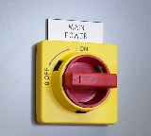
Figure 3-2
Main Disconnect

- Remove any lock-out/tag-out devices and rotate the main power disconnect clockwise to ON
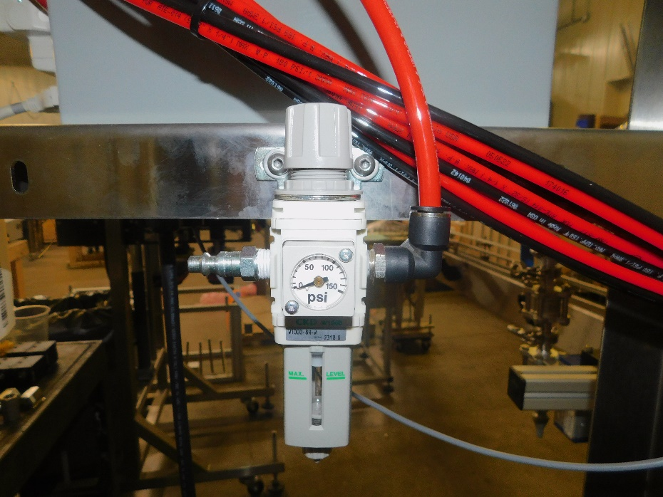
Figure 3-3
Main Air Filter Regulator

Quick Disconnect Air Inlet
Pressure Adjustment Knob
Pressure Indicator Gauge
Air Filter Particulate and Condensate Trap

Keeping clear of any moving parts and assemblies, remove any lock-out/tag-out devices and rotate the main air disconnect clockwise to ON

- Verify that sufficient containers to be processed are available to be supplied to the machine.
- On the operator interface, press Start to begin sorting.
- If machine does not perform properly, refer to the appropriate mechanical adjustments or timers.

MECHANICAL ADJUSTMENTS
The sorter may require change parts to switch between different caps which are easily swapped with toolless thumb knobs. The air jets are also manually adjusted with toolless knobs and indicators for easy repeatability. The pressure of each jet is also adjustable with thumb knobs on flow controls.

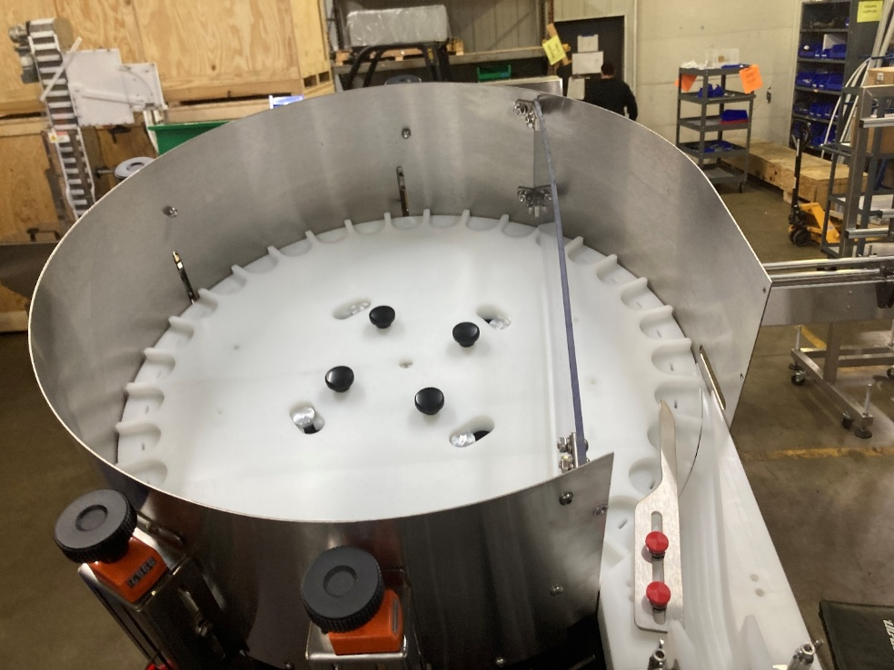
Cork Guides
Air Jet Adjusters
Thumb Knobs
Sorting Disk

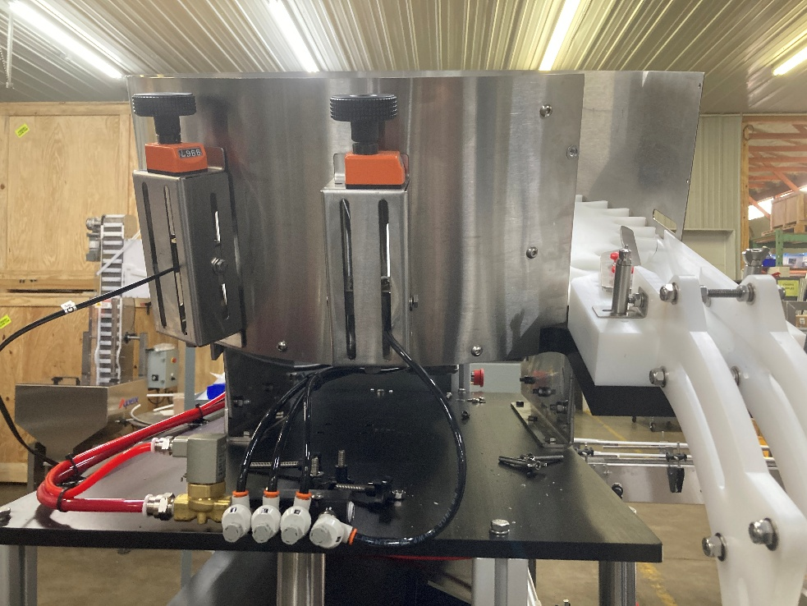
Air Jet Air Solenoid
Cork Chute
Air Jet Height Adjusters
Air Jet Pressure
Adjusters

  - THEORY OF OPERATION

Utilizing timers accessed through the touch screen controls, the sorting disk will rotate tumbling caps and with the assistance of manually adjusted air jets will orientate caps and feed them into a chute. The bowl will be replenished by a bulk elevator when level is low if used.

ELECTRICAL
  - FRONT PANEL CONTROLS
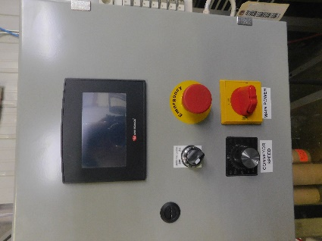
Figure 5-4
Front Panel Controls
Typical controls available to the operator are shown in Fig 5-4
The primary operator interface touch screen, Emergency Stop button, Main Power Disconnect, Heater temp and Conveyor Controls are generally mounted on the front panel.

  - AIR SOLENOIDS
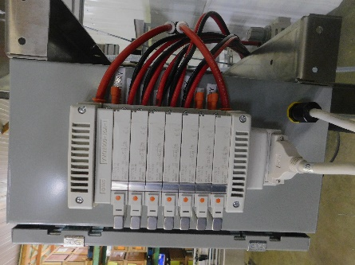
Figure 5-5
Air Solenoids

Air solenoids, typically mounted to the side, or rear, of the main control box, provide pneumatic logic control for the machine operation. An electrical signal, sent from the PLC, activates the solenoid attached to the air valve, switching the air pressure from one port to the other.
Solenoids may be manually activated by pressing the orange button located on the face of the solenoid assembly to assist with troubleshooting.

Alternate air solonoid configurations are possible.
Refer to machine specific documentation.

OPERATOR INTERFACE SCREENS
  - MAIN CONTROL SCREEN
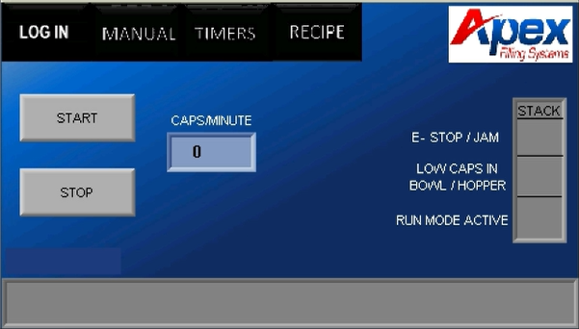
Figure 7-1
Main Screen
From the main control screen, the various sub-screens and timers can be accessed.
Pressing the top buttons (in Fig 7-1 “LOG IN, MANUAL, TIMERS, and RECIPE”) will access sub-menus described in the following sections:
LOG IN: Section 7.3
MANUAL: Section 7.6, 7.7
TIMERS: Section 7.8
RECIPE: Section 7.10

- Pressing START will start the automatic mode
- Pressing STOP will stop automatic mode
- Caps/Minute will be displayed while actively sorting caps
- Stack light will illuminate depending on machine status only while in auto mode.
RED- Estop pressed or jam detected. Once jam is cleared you will press the pop up JAM CLEARED button.
AMBER- Bulk elevator hopper cap level detected as low or sorting bowl has been detected low for extended period of time.
GREEN- Run Mode is Currently Active with no Faults
  - LOG IN
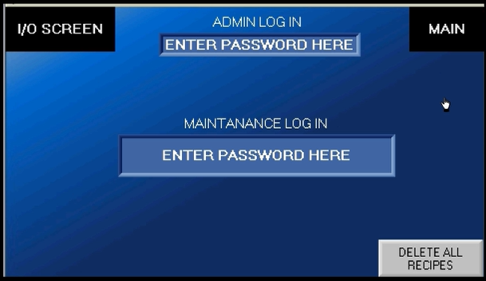
Figure 7-2
Setup screen
- I/O Screen will take you to view the active inputs and outputs screen
- Maintenance log in will allow you access critical timers and function
- Delete All recipes will clear data stored for all recipes
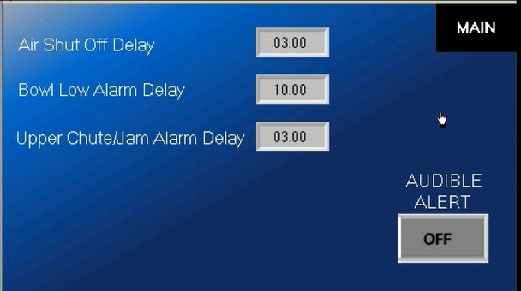
- Air shutoff delay will be how long the main air stays on after the sorter shuts off
- Bowl low alarm delay will delay an amber stack light in case of low bowl level
- Upper chute jam alarm delay will delay a red stack light upon jam detection

  - Manual
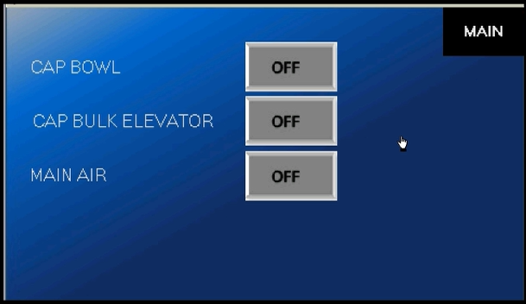
The manual screen will stop auto cycle and allow manual operation of selected function
  - Timers

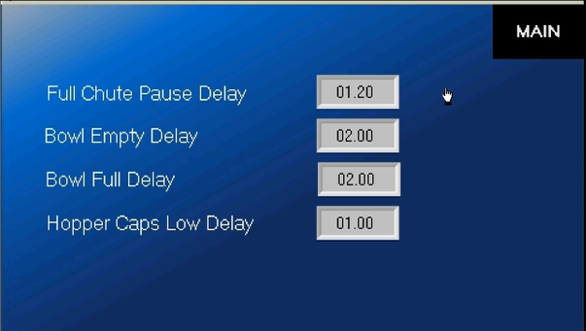

- Full chute pause- Delay in pause of sorting after caps reach full chute sensor
- Bowl empty delay- Delay in bulk elevator turning on
- Bowl full Delay- Delay in bulk elevator turning off
- Hopper caps low Delay- Delay in Bulk elevator hopper low alarm

RECIPE SCREEN
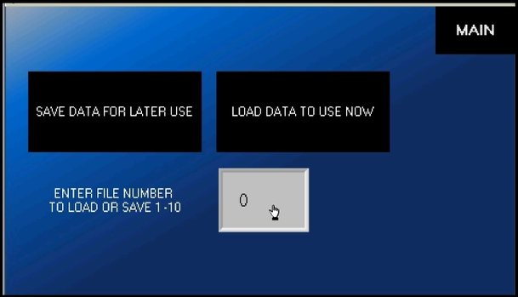
This screen allows the operator to save or load all of the timers which are specific to different caps or setups. Pressing directly on the numeral will pop up the numeric entry window. Press the desired address (1-10) and either save or load the data by pressing the associated button

TROUBLESHOOTING
7.2GENERAL TROUBLESHOOTING

SYMPTOMS | POSSIBLE RESOLUTIONS
Machine does not power-up | Verify inlet power is active
Machine does not power-up | Verify Main Disconnect is rotated to ON
Machine does not power-up | Check Main Fuses or Circuit Breakers
Machine does not power-up | Check control transformer (220VAC to 110VAC) and connections
Caps Upside Down | Check main air pressure
Caps Upside Down | Verify all appropriate air jets are functioning  And adjusted correctly
Caps Upside Down | Correct change parts for cap
Unit powers, but will not cycle | Not on manual screen
Unit powers, but will not cycle | Check that E-Stop is pulled out
Unit powers, but will not cycle | Check for drive Faults
No caps in bowl | Check elevator hopper
No caps in bowl | Check drive faults
No caps in bowl | Check bowl level switch

SERVICING
CLEANING PROCEDURE
It is important that the machine is kept clean of dirt, broken caps, dust, etc. as these will reduce the wear life of the unit. The machine should be cleaned with water or soap at regular intervals. Stronger detergents are often used in the food industry and can be corrosive on the machine components. Therefore, the machine should be washed down thoroughly immediately after cleaning with any harsh detergents.


WARNING: When using a high-pressure pistol with cold and hot water, or steam for cleaning, do not spray near any electrical enclosures.

FACTORY CONTACT INFORMATION
CONTACT APEX DIRECTLY
Apex Filling Systems, LLC
Spare Parts
Direct: (219) 402-0211
Service: (219) 363-5463
1001 Eastwood Rd
Michigan City, Indiana 46360 USA
(219) 575-7493
www.apexfilling.com
NOTES

