

Eco Overflow Operations Manual

V1.1

TABLE OF CONTENTS
- SAFETY Page
  - GENERAL SAFETY 3
  - ELECTRICAL SHOCK 3
  - CONTACT MATERIALS COMPATIBILITY 3
  - SAFETY COMPLIANCE LIABILITY 4
  - CONVENTIONS 4
- MACHINE FEATURES & SPECIFICATIONS
  - INTRODUCTION 5
  - FEATURES & BENEFITS 5
  - UTILITY REQUIREMENTS 5
- INSTALLATION & START-UP
  - INSTALLATION PROCEDURES 6
  - START-UP & COMMISSIONING 6
- MECHANICAL ADJUSTMENTS
  - FILLER COMPONENT OVERVIEW 8
  - THEORY OF OPERATION 9
  - CONTAINER GUIDE RAIL AND INDEXING GATE ADJUSTMENTS 10
  - CONTAINER SENSOR ADJUSTMENTS AND LOCATIONS 11
  - FILL BAR ADJUSTMENTS 11
  - FILL HEAD SIDE TO SIDE ADJUSTMENT 12
  - DRIP TRAY HEIGHT ADJUSTMENT 12
  - NECK LOCATOR ADJUSTMENT 13
  - DIVE HEAD AND STROKE ADJUSTMENT 14
- LIQUID HANDLING
  - FLOAT SYSTEM 13
  - SUPPLY pump 14
  - Pressure Pump 14
  - Fill Head 15
- ELECTRICAL
  - FRONT PANEL CONTROLS 16
  - AIR SOLENOIDS 16

- OPERATOR INTERFACE SCREENS
  - MAIN CONTROL SCREEN 17
  - Setup SCREEN 18
  - ASU SCREEN 19
  - Timers SCREEN 1 20
  - timers SCREEN 2 21
  - Manual SCREEN 22
  - I/O SCREEN 23
  - Recipe SCREEN 24
  - LoGIN SCREEN 25

- TROUBLESHOOTING
  - GENERAL TROUBLESHOOTING 26
- SERVICING
  - CLEANING PROCEDURE 27
- FACTORY CONTACT INFORMATION
  - CONTACT APEX DIRECTLY 28

SAFETY
  - GENERAL SAFETY
Apex Filling Systems, LLC (APEX) manufactures and designs all of its products so they can be operated safely. However the primary responsibility for safety rests with those who use and maintain these products. The following safety precautions are offered as a guide that if conscientiously followed, will minimize the possibility of accidents throughout the useful life of this equipment. The safety of personnel, equipment and plant facilities should be considered during equipment operation and with each changeover of product, or any machine modifications.

Only those who have been trained and delegated to do so and have read and understood this operator's manual should operate the equipment. Failure to follow the instructions, procedures and safety precautions in this manual can result in accidents and injuries.

DO NOT modify the equipment except with written factory approval. Unauthorized equipment modifications will void the warranty.

Each day walk around the equipment and inspect for leaks, loose parts, missing or damaged components, and parts out of adjustment. Perform all recommended maintenance noted in this manual.

EQUIPMENT SHOULD ALWAYS BE DE-ENERGIZED (POWER AND AIR) BEFORE MAKING MECHANICAL ADJUSTMENTS.

  - ELECTRICAL SHOCK
- To avoid electrical shock hazard, make sure this equipment is properly grounded.
- Dangerous voltages are present within the electrical enclosures. DO NOT operate this equipment with electrical covers open or removed.
- Keep all parts of the body, hand held tools, or other conductive objects away from exposed live-parts of the electrical system. Maintain dry footing and stand on insulating surfaces. DO NOT contact any portion of the equipment when adjusting or making repair to exposed live parts of electrical system.
- Attempt repairs only in a clean, dry, well-lighted, and ventilated area.

  - CONTACT MATERIALS COMPATIBILITY
APEX endeavors to make all contact parts compatible with buyer's products, if known. Because of the wide variety of possible products, Apex Filling Systems, LLC cannot be responsible or liable for ensuring compatibility of contact material with the products. Evaluate material compatibility prior to machine use. Failure to follow this procedure can result in machine damage, fire, operator injury or death

  - SAFETY COMPLIANCE LIABILITY
APEX endeavors to make machinery as safe to operate as possible. National, state and local laws related to safety in the workplace apply primarily to the responsibilities of the employer, and not the equipment manufacturer. The seller agrees to cooperate with the buyer in finding feasible answers to compliance problems. However, because APEX has little control of the many factors which may significantly affect the environment in which this equipment is installed, the seller does not warrant this equipment to be in compliance with OSHA or any like state or local laws or regulations. It is the buyer's responsibility to provide the modifications necessary to assure compliance with the laws and regulations at the point of installation.
A complete inspection of product is necessary until the machinery is proven to produce acceptable results. This should also be performed after every changeover.

  - CONVENTIONS
To ensure the safety of personnel which will install, adjust, maintain and operate this equipment, it is imperative that they understand the dangers, warnings and caution notices. It is important to understand the signal words that may be used throughout this manual.

 | Alerts to immediate hazard, which will result in death or severe personal injury, if not avoided
 | Alerts to a hazard which will result in serious injury, or death in some cases, if not avoided.
 | Alerts to a potential hazard that may result in a serious personal injury, if not avoided. It also alerts against an unsafe practice that will permanently damage equipment or property.
 | Indicates a suggestion as to how to use or adjust the equipment for best product results.
 | Points out a proper use that will avoid damage to the equipment, or will extend the life of the parts.

MACHINE FEATURES & SPECIFICATIONS
  - INTRODUCTION
APEX fillers are designed to be easy to setup and maintain, capable of providing years of reliable service. Versatile by design, APEX fillers can accommodate a wide variety of product and container configurations, often without the need for change parts. Modular design allows for fully automatic or semi-automatic systems. Tool-less adjustments are available, and allow for easy and quick changeover for various product and container combinations. Operator controls are easily accessed via the front panel of the unit.
  - FEATURES & BENEFITS
- Easy Changeover
Simple mechanical adjustment for different bottle sizes. Quick to changeover, simple to use and easy to clean
- Robust
Anodized aluminum and stainless steel shells, frames, legs and housings maximize the working life of your machine, and minimize maintenance costs and downtime
- Customizable
Whatever the production need, APEX has a design to meet
- Flexible
Versatility and Simplicity are intrinsic to the design. Many container sizes and shapes, and many products can be run on one machine
  - UTILITY REQUIREMENTS
Compressed Air Consumption: Clean, dry (non-oiled) compressed air 80-100psi /
up to 20cfm depending on options
Refer to machine specific documentation.
Electrical Consumption: 110VAC / 60Hz / Single Phase / 20A depending on options
Alternate electrical supply configurations are possible.
Refer to machine specific documentation.

INSTALLATION & START-UP
  - INSTALLATION PROCEDURES
The filler assembly should be placed on a solid, level foundation, with the fill head mount bar centered over the container conveyor. The main filler frame should be leveled using threaded leveling pads or other suitable means to secure the equipment in place. Electrical connections should be properly terminated into the main electrical enclosure by properly trained technicians, and appropriate supply voltage, proper phase and adequate supply amperage should be verified prior to powering up the equipment. Sufficient compressed air should be available and connected for proper operation.

  - START-UP & COMMISSIONING

This manual should be read completely before powering-up the machine. Commissioning of the machine should be performed by a trained technician only after complete understanding of the machine, and with products that match samples indicated to APEX Consultants, LLC if supplied. After the machine is adjusted for the bottle and product combination, the machine can be put into operation with the following steps.
Figure 3-1
Emergency Stop
- Check the machine to see that guards are in place
- Check the mechanical system for loose or missing parts
- Ensure the E-STOP button is depressed, and the unit is clear of personnel.
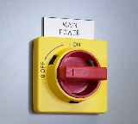
Figure 3-2
Main Disconnect

- Remove any lock-out/tag-out devices and rotate the main power disconnect clockwise to ON
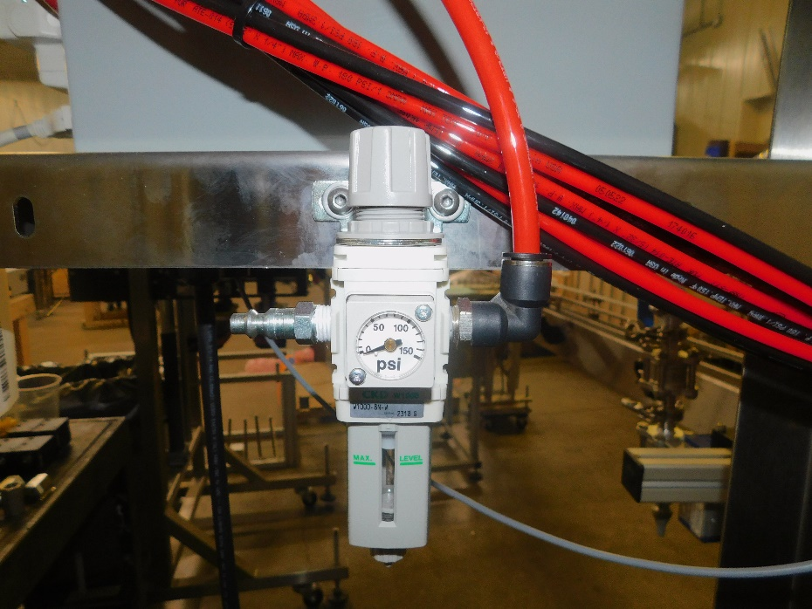
Figure 3-3
Main Air Filter Regulator

Quick Disconnect Air Inlet
Pressure Adjustment Knob
Pressure Indicator Gauge
Air Filter Particulate and Condensate Trap

Keeping clear of any moving parts and assemblies, remove any lock-out/tag-out devices and rotate the main air disconnect clockwise to ON

- Verify that sufficient containers and product to be filled are available to be supplied to the filler
- On the operator interface, press Cycle Start (or equivalent, depending upon controller configuration) to begin the container indexing and filling cycle.
- If fill levels are incorrect, or machine indexing does not perform properly, refer to the appropriate mechanical adjustments (Sec 4.1) to rectify, or adjust the filling and indexing program timers (Sec 7.1).

MECHANICAL ADJUSTMENTS
  - FILLER COMPONENT OVERVIEW

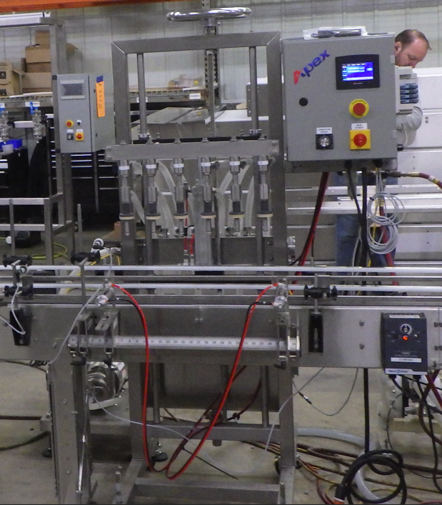
PRODUCT TANK
SUPPLY PUMP
VALVE BANK
INDEXING
DIVE HEIGHT
ADJUSTMENT
CONTROL BOX
FILL BAR
FILL HEAD
Many typical filler assembly components are shown in Figure 4-1 for reference. As the design is modular, there is a wide variety of additional components not shown, such as a drip tray, neck locator assembly, and other optional components, as per application requirements.

  - THEORY OF OPERATION

APEX automatic fillers utilize a container conveying system, typically a flat tabletop chained conveyor, to move containers into and out of the filling area. Container location is precisely controlled with the use of guide rails, and indexed using either air cylinders (commonly referred as “gates” or “pins”) to stop and release containers, or using star wheels designed per container, with pockets for container control.
Utilizing timers accessed through the touch screen controls, containers are automatically indexed into the fill area. For pin-indexing setups, an entry gate holds back empty containers, and an exit gate holds back the containers to be filled. The process conveyor will often be stopped while filling containers to increase the stability of the containers.
A consistent volume of product in the hopper tank is maintained using a float system. Filling accuracy can be achieved using timers accessed via the operator interface controls.
Maximum/optimal fill speed achievable is dependent upon many factors, many of which are addressed by the design of the machine, for instance:
- Size of the product tubing and valves
- Output volume capacity of supply pump or product supply system
The fill cycle starts once the containers have been counted via an electrical container sensor. Depending upon the equipped options, the drip tray retracts, the bottle neck locators extend, the fill bar dives, and the fill pump operates for the amount of time set in the operator interface.
Once the containers are full and the fill cycle has finished, the full containers are indexed out of the fill area to down-line operations (capping, labeling, etc), and empty containers are indexed in to the fill area, ready for the next fill cycle.

  - CONTAINER GUIDE RAIL AND INDEXING GATE ADJUSTMENTS
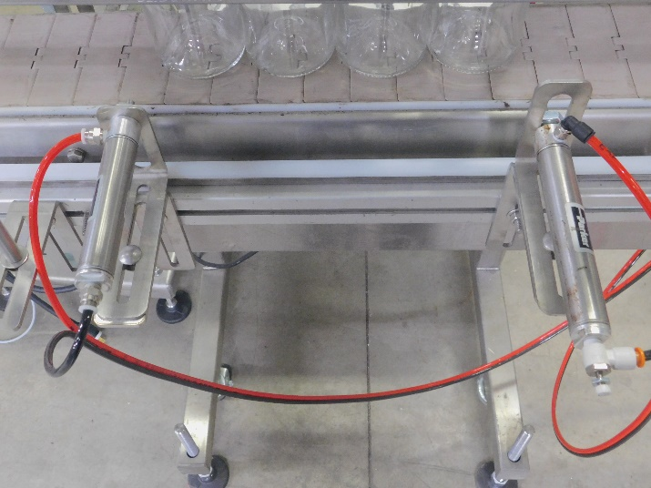
For containers to move properly down the conveyor, guide rails must be adjusted so that containers move smoothly, without binding, in a uniform manner. Guide rails will typically be set toward the base of the container for best results. Difficult-to-control containers may require an alternate setup (multiple rails, special containment, etc) to effectively control the location of the containers. Guide rails are typically adjusted in/out and up/down with turnbuckles which hold the guide rail rods in place.
Entry Gate
Figure 4-2
Guide Rails and Indexing Gates

Exit Gate
Container Guide Rails
Index Gate Mount Rail
Cylinder Air Flow Control
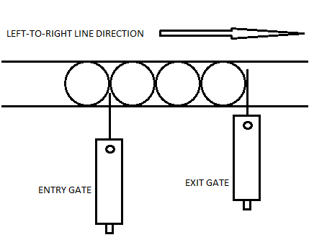
Figure 4-2 shows a typical (left-to-right) set up of guide rails and indexing gates. Containers are situated in the fill area by the Entry Gate and Exit Gate locations. The gates or pins, are mounted in place with L-brackets mounted to a sliding mount rail as shown, and are positioned and locked into place with standard nuts and bolts.
Figure 4-3
Indexing Gate Positioning

The exit gate is set so that it extends over more than half of the container diameter, so the containers are positively stopped during the indexing cycle. The entry gate only extends far enough to hold back incoming (empty) containers from moving past it, without affecting their position when extended, as shown in Fig 4-3.

Air cylinders are typically equipped with air flow control valves to adjust the speed which the cylinders will operate. Turn clockwise to slow the extension or retraction, counter-clockwise to speed.

  - CONTAINER SENSOR ADJUSTMENTS AND LOCATIONS

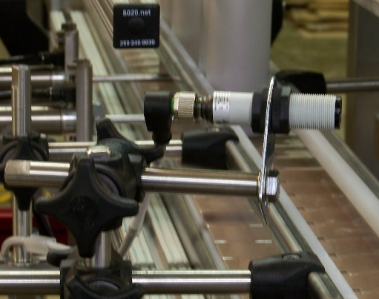
Sensors are positioned along the container path on the conveyor (such as shown in Fig 4-4) to count and/or verify the container position. A variety of sensors can be utilized, depending upon the type of container to be sensed (clear glass, plastic bottle, metal can, etc.) Sensors located prior to the fill area count the proper number of containers entering the fill area and verify sufficient containers are available prior to the fill area. Sensors located downstream from the fill area will sense if a backup has occurred, and will pause the fill operation until the backup or jam has cleared.
Figure 4-4
Typical Container Sensor

The container count sensor is positioned so that it reads empty containers on the conveyor at least one full cycle’s worth of containers prior to the entry gate.

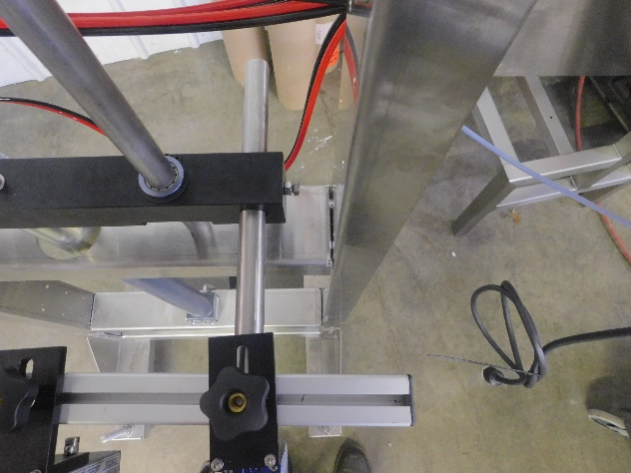
Figure 4-5
Fill Bar Horizontal Adjustment

Fill Bar Horizontal Mounting Shaft
Lock Bolt and Nut

  - FILL BAR ADJUSTMENTS
The fill bar should be centered over the container conveyor so the fill heads line up above the container necks. The fill bar is adjusted forward and backward by loosening the hex head lock nut and bolt which locks the horizontal mount shaft.
  - FILL HEAD SIDE TO SIDE ADJUSTMENT
Fill heads can be adjusted side to side by loosening the adjustment Bolts and sliding the heads so they are aligned with the container necks. Likewise, if equipped, the neck locator fingers can be adjusted to positively contain the container necks against the neck rail.
The fill bar height is adjusted with a manual crank wheel located at the top of the frame.
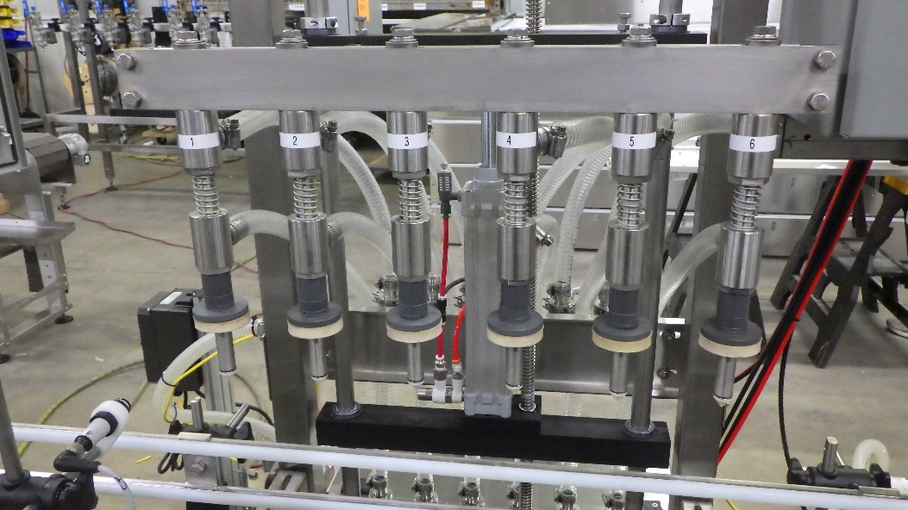
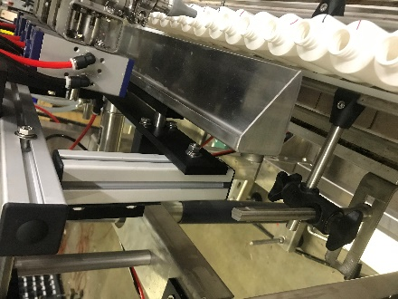
Drip Tray Mounts
Figure 4-7
Drip Tray Height Adjustment

  - DRIP TRAY HEIGHT ADJUSTMENT
The optional drip tray assembly should be adjusted so that, when extended, it is slightly below the bottom of the nozzle tips. For a machine equipped with the optional diving head assembly, the heads should be in the up position when adjusting the drip tray height.

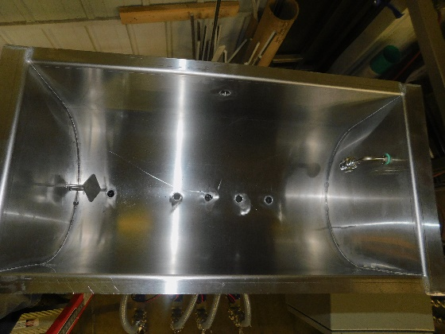
LIQUID HANDLING
Figure 5-1
Product Float Switch

Ball Float
Vent Port
  - FLOAT SYSTEM

Inside the hopper tank is a ball float which maintains the product level to feed the fill heads consistently and repeatedly. When the product is supplied to the hopper tank up to the level which the Ball Float Switch moves to its upper stop, the product inlet will close and/or the supply pump will turn off.

Float switches are reversible. If the float ball is removed, and re-installed upside-down, it will send reversed signals to the controller, causing a fault, or possibly overflowing the hopper tank.
It is important to verify proper orientation after cleaning or disassembly to avoid problems.

  - SUPPLY PUMP
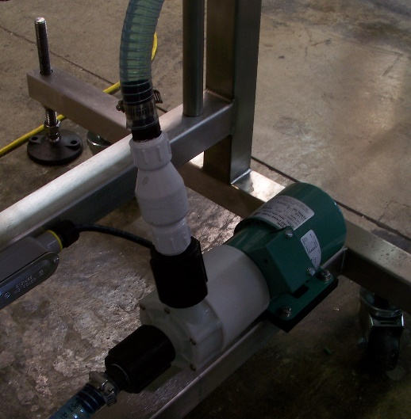
Feeding the hopper tank to maintain consistent levels is generally achieved using a pump to feed product into the hopper. Occasionally, if bulk product is located above the level of the hopper tank, gravity feed may be utilized instead. Most importantly, the supply must be able to match the speed of the fill, so that a constant level of product is maintained in the hopper tank.
Figure 5-2
Supply Pump

Product Inlet
Tubing to Hopper Tank

  - PRESSURE PUMP
Generally attached to the frame is a pressure pump typically with a check valve to eliminate drain back. This pump will be commanded off and on by the filler when needed to fill containers.

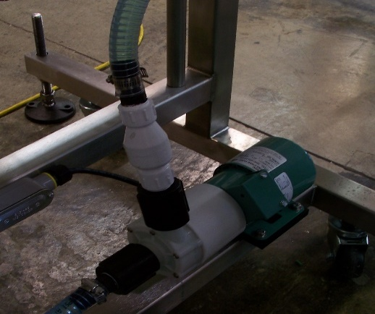
Figure 5-3
Pressure Pump

Product Inlet
From Tank
Tubing to Manifold

  - FILL HEAD
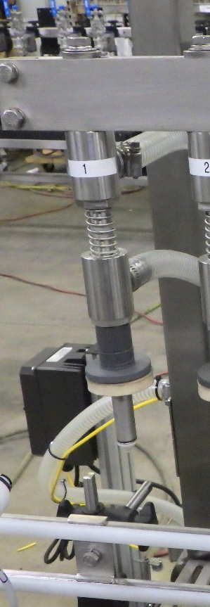
Fill heads contain a set of spacers that will be interchanged to set the fill level in the containers. To adjust you will dive the heads into a container and adjust the compression of the spring by lowering the head dive adjustment wheel until the spring on the fill head is almost compressed. You will then change out the spacers to get the overflow port in the nozzle to line up at your desired level, more spacers is a higher level less spacers will lower the level.
SEALING WASHER
FILL LEVEL
SPACERS
OVERFLOW PORT
INLET PORT

ELECTRICAL
  - FRONT PANEL CONTROLS
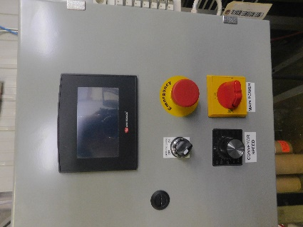
Figure 5-4
Front Panel Controls
Typical controls available to the operator are shown in Fig 5-4
The primary operator interface touch screen, Emergency Stop button, Main Power Disconnect, and Conveyor Controls are generally mounted on the front panel.
Other toggles may be present, depending upon the configuration, please refer to machine specific documentation for custom configurations.

  - AIR SOLENOIDS
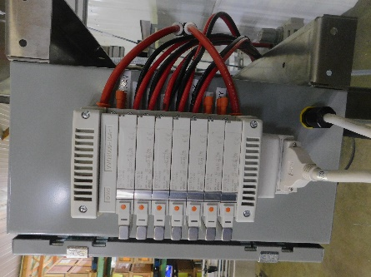
Figure 5-5
Air Solenoids

Air solenoids, typically mounted to the side, or rear, of the main control box, provide pneumatic logic control for the machine operation. An electrical signal, sent from the PLC, activates the solenoid attached to the air valve, switching the air pressure from one port to the other, extending or retracting the connected air cylinder (indexing gates, dive cylinder, drip tray cylinder, etc)
Solenoids may be manually activated by pressing the orange button located on the face of the solenoid assembly to assist with troubleshooting.

OPERATOR INTERFACE SCREENS
  - MAIN CONTROL SCREEN
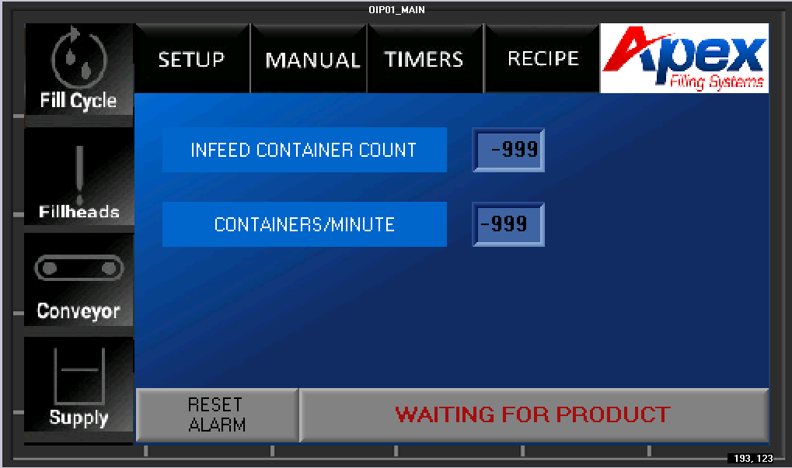
Figure 7-1
Main Screen
From the main control screen, the various sub-screens and timers can be accessed.
Pressing the top buttons (in Fig 7-1 “SETUP, MANUAL, TIMERS, and RECIPE”) will access sub-menus described in the following sections:
SETUP: Section 7.3
TIMERS: Section 7.6, 7.7
MANUAL: Section 7.8
I/O SCREEN: Section 7.9
RECIPE: Section 7.10
LOGIN: Section 7.11

  - SETUP SCREEN
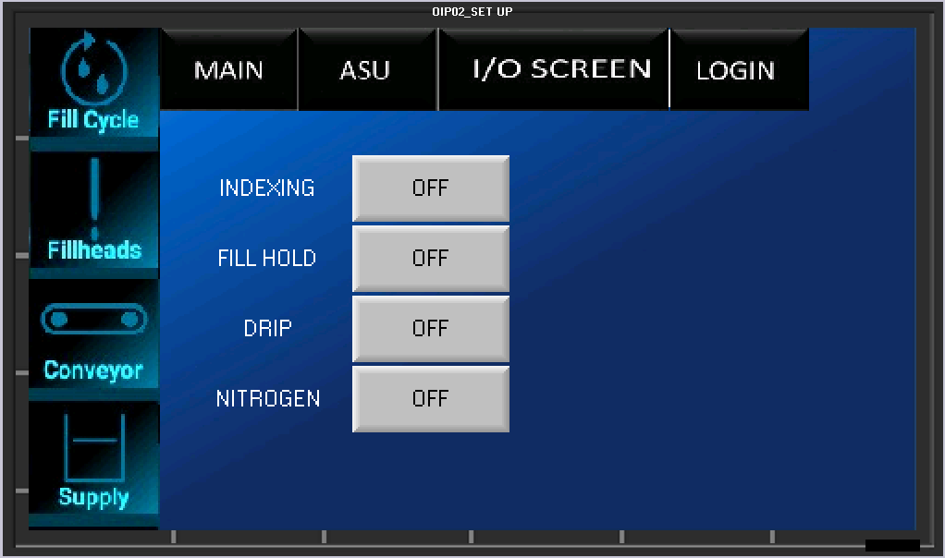
Figure 7-2
Setup screen
- INDEXING: Sets whether pin indexing will be used for container movement, or if containers will be hand placed or controlled with a method other than standard pin indexing
- FILL HOLD: Will not fill containers unless tank is full
- DRIP TRAY: Sets whether there is active
- Nitrogen: Turns on Nitrogen activation

  - ASU SCREEN 1
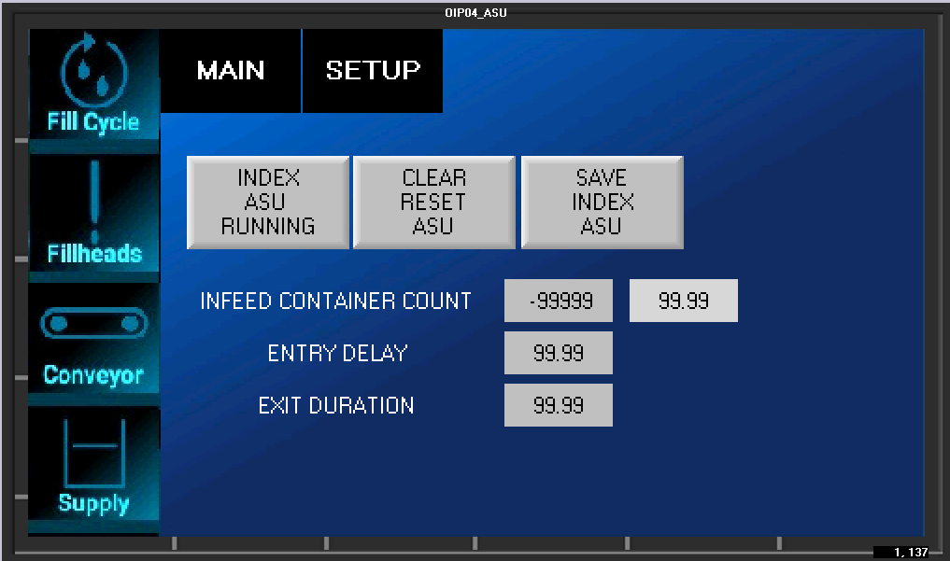
ASU Screen 1 handles the indexing ASU
Basic sequence of ASU indexing setup (pin indexing):

    - Ensure the entry and exit gates are properly aligned in the fill area and the guide rails are set properly
    - Ensure the count eye is accurately reading containers
    - Set up sufficient containers to fill the fill area plus any additional containers necessary to reach the count eye
    - The containers should be set up-stream from the entry gate, and the fill area should be clear of containers
    - Press START ASU INDEX to activate the conveyor, the entry gate will open, and the count eye will read the containers
    - When the count eye has read the proper number of containers, the indexing ASU has finished
    - Press SAVE INDEX ASU

  - TIMERS SCREEN 1
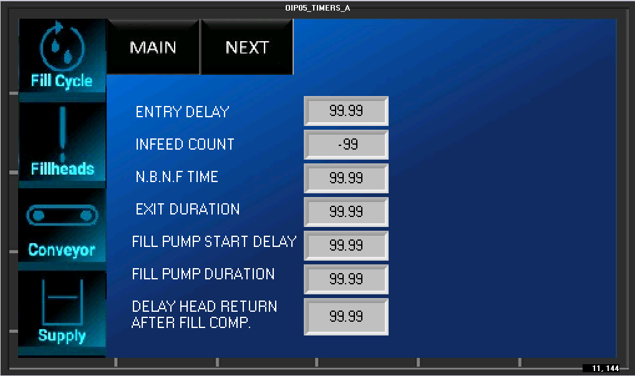
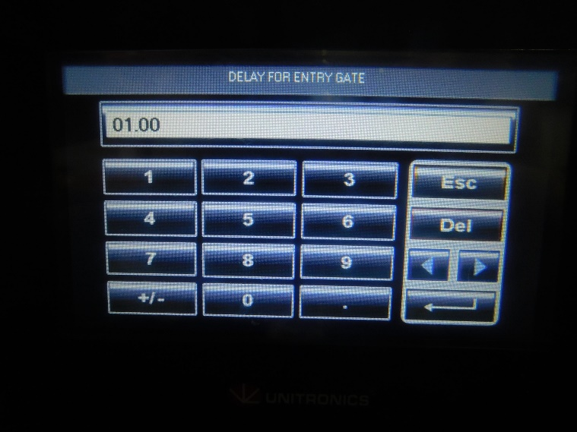
Figure 7-6
Direct Numerical Entry

From this pop-up window, numbers can be directly entered into the program parameters. Pressing ENTER (the lower rightmost button) will save the entry and return to the original screen.
Pressing ESC (the top right button) will return to the original screen without altering the preset count.
Entry Delay: Sets the gap between filled set and new set of containers entering fill zone.
Infeed Count: Number of containers counted each cycle
NBNF: No bottle no fill timer is the amount of time the count sensor must be blocked after count
Exit duration: The amount of time needed for containers to move from entry to exit pin.
Fill pump start delay: How long after initiating cycle before the fill pump activates
Fill pump duration: How long the fill pump runs in cycle.
Delay head return after fill: How long the heads will remain down after fill for overflow balance.
  - TIMERS SCREEN 2
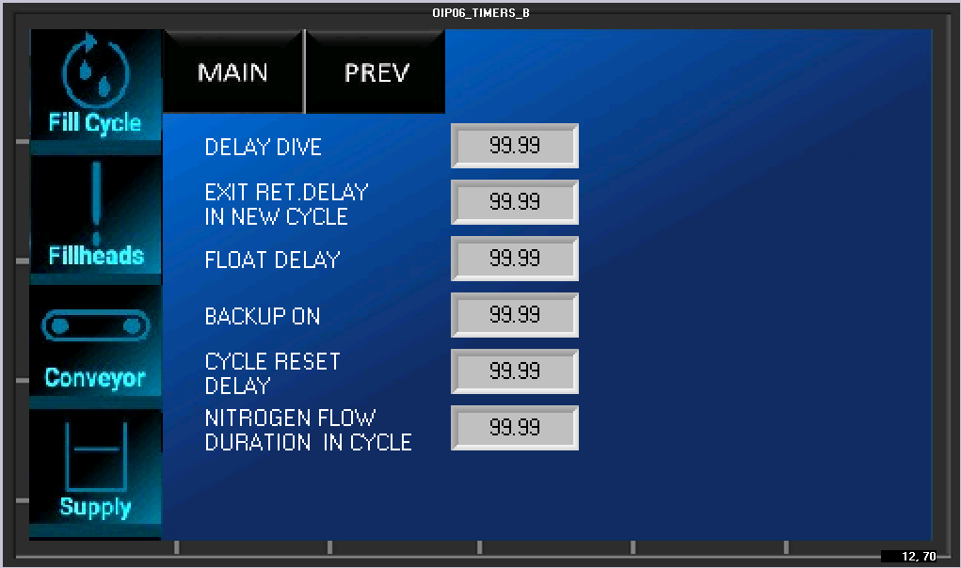

The second Set Timers Screen is functionally equivalent to the first Set Timers Screen.
Delay Dive: How long after containers are in place before the heads will dive.
Exit retract delay: How long after fill complete until containers begin to index out.
Float Delay: How long after float drops before product supply activates.
Backup on: How long line back up sensor is blocked before a fault.
Cycle restart delay: How long after fill complete before cycle is restarted. Typically used to slow filler for other equipment down the line.
Nitrogen Flow Duration: How long will nitrogen output be held on during each cycle.
  - MANUAL SCREEN
The blue buttons act as toggle switches, activating the associated module:
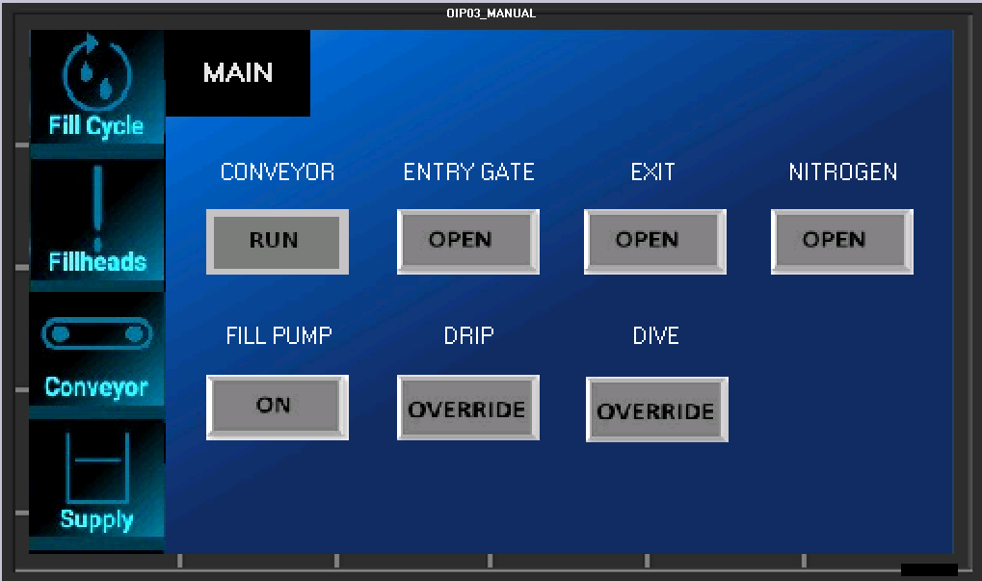

CONVEYOR (AUTO or RUN CONTINUOUS)
Activating this toggle will bypass the conveyor controls, allowing the conveyor to either run for indexing, and stop during filling (AUTO) or to run continuously (RUN)

ENTRY GATE (Enabled or Disabled)
Activating this toggle will bypass the entry cylinder pin/gate controls, allowing the entry cylinder to either open and close for standard pin indexing (Enabled) or to remain open (Disabled)

EXIT GATE (Enabled or Disabled)
Activating this toggle will bypass the exit cylinder pin/gate controls, allowing the exit cylinder to either open and close for standard pin indexing (Enabled) or to remain open (Disabled)

NITROGEN
Activating will hold nitrogen purge on

Fill Pump
Activating Will run the fill pump

Drip
Activating will toggle drip tray if equipped

Dive
Activating will dive the fill bar

7.8 I/O SCREEN
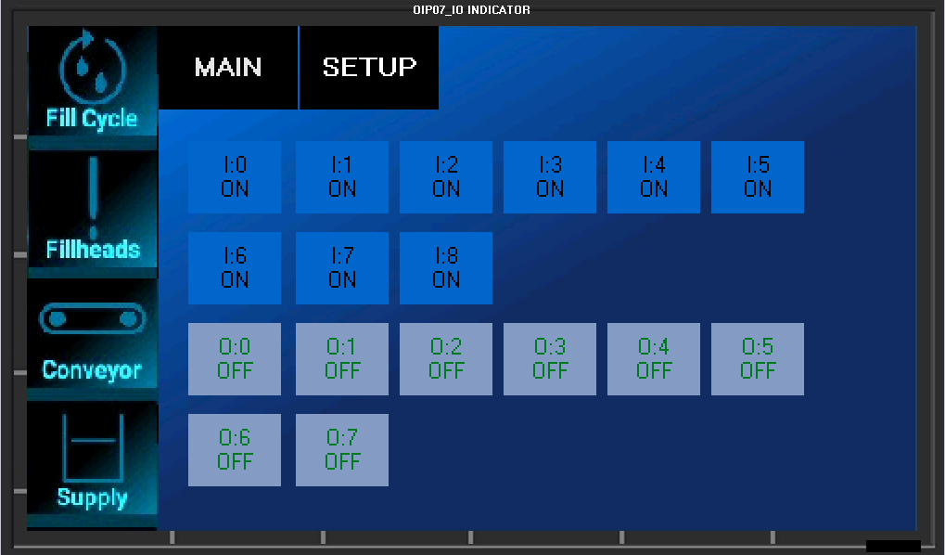
  - RECIPE SCREEN
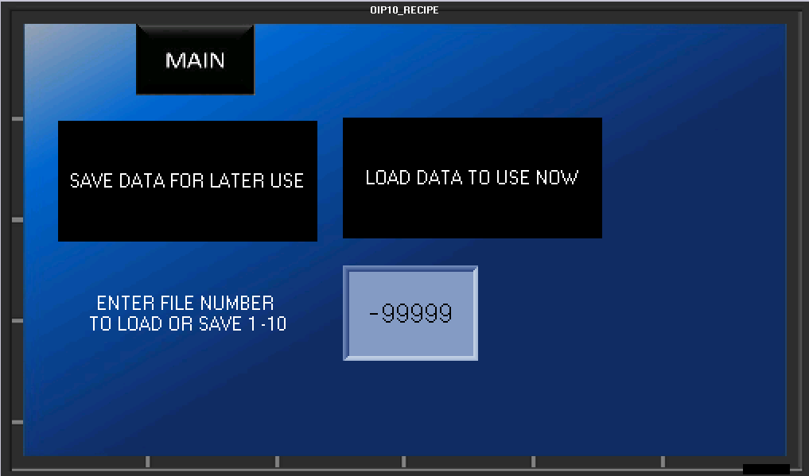
This screen allows the operator to save or load all of the timers (indexing and filling) which are specific to different containers or setups. Pressing directly on the numeral will pop up the numeric entry window. Press the desired address (1-10) and either save or load the data by pressing the associated button

  - LOGIN SCREEN
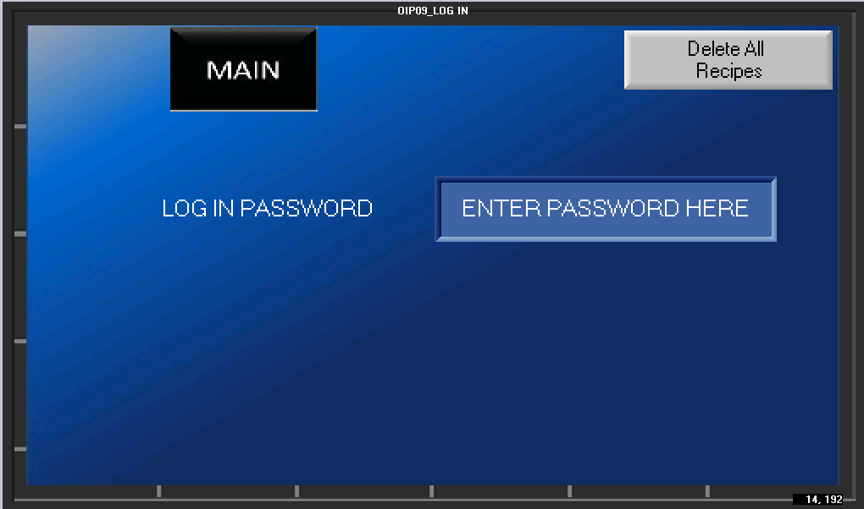

The log in screen will be used for factory setup. On this screen you may also clear all recipes in a factory reset or to clear a recipe corruption state.

TROUBLESHOOTING
8.2GENERAL TROUBLESHOOTING

SYMPTOMS | POSSIBLE RESOLUTIONS
Machine does not power-up | Verify inlet power is active
Machine does not power-up | Verify Main Disconnect is rotated to ON
Machine does not power-up | Check Main Fuses or Circuit Breakers
Machine does not power-up | Check control transformer (220VAC to 110VAC) and connections
Fill levels are inconsistent | Check that float system is properly supplying the hopper tank
Fill levels are inconsistent | Verify sufficient air pressure is available
Fill levels are inconsistent | Verify fill nozzles have no clogs, clean if needed
Unit powers, but will not cycle | Check that the line backup sensor is located properly, and clear of obstruction
Unit powers, but will not cycle | Check that E-Stop is pulled out
Unit powers, but will not cycle | Check that Reset Power button has been engaged (if equipped)
No product in supply tank | Check for proper air supply
No product in supply tank | Check pump motor starter relay in control box (if equipped)
No product in supply tank | Check supply control valve on supply tank
No product in supply tank | Check float switches for proper operation
No product in supply tank | Ensure tank drain valve is closed
No product in supply tank | Check that product supply is enabled in the Operator Interface

SERVICING
CLEANING PROCEDURE
It is important that the machine is kept clean of dirt, broken glass, sand, etc. as these will reduce the wear life of the air cylinders and pump seals, o-rings, etc. The machine should be cleaned with water or soap at regular intervals. Stronger detergents are often used in the food industry and can be corrosive on the machine components. Therefore, the machine should be washed down thoroughly immediately after cleaning with any harsh detergents.


WARNING: When using a high-pressure pistol with cold and hot water, or steam for cleaning, do not spray near any electrical enclosures.
If the machine is to sit dormant for more than 48 hours (or less, depending upon the product) it is good practice to completely flush the product lines, pumps, and fill heads with clean water. If solvent is needed to dissolve product effectively, it is equally important to flush with clean water after cleaning product residue. Harsh detergents and solvents can harm seals and tubing and should be cleared from the system.

FACTORY CONTACT INFORMATION
CONTACT APEX DIRECTLY
Apex Filling Systems, LLC
Spare Parts
Direct: (219) 402-0211
Service: (219) 363-5463
1001 Eastwood Rd
Michigan City, Indiana 46360 USA
(219) 575-7493
www.apexfilling.com
NOTES

